From the ABCs to Emerging Mathematical Theories, Masterkeying is STILL Locksmithing's Mt. Everest

**ALOA 2004  
FLOORPLAN INSIDE!!**

Ht^^^t***^^*****4e^^**2~OIGlT 303

Breck H. Camp CML PO Box 47070 Atlanta GA 30362-0070

**Plus: Cycle Chronicles Goes Harley,** luHillimillnlliinlilllmllmlmlllHilMilllMl

Fitting and Cloning a Honda Transponder,

Meeting ALOA 2004's Home State Hosts,

Inside The Safe Technician's Reference Manual, and more!

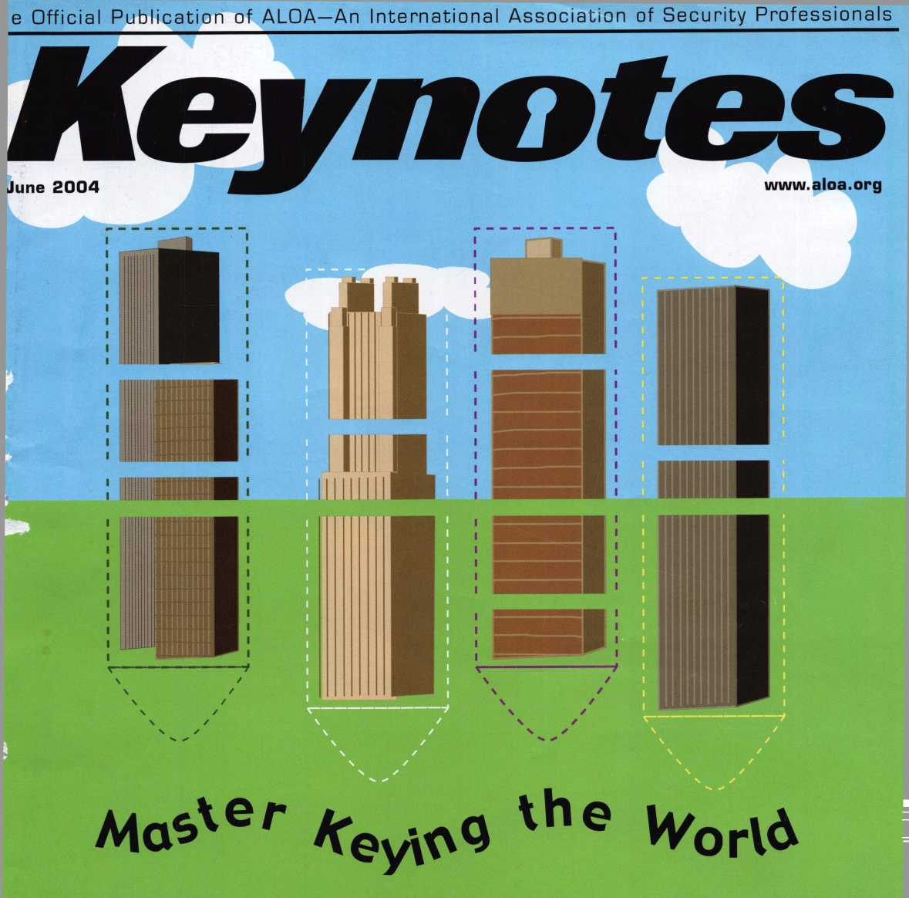

*An American Original*

**FORGING TIES WITH PEOPLE, PRODUCT**

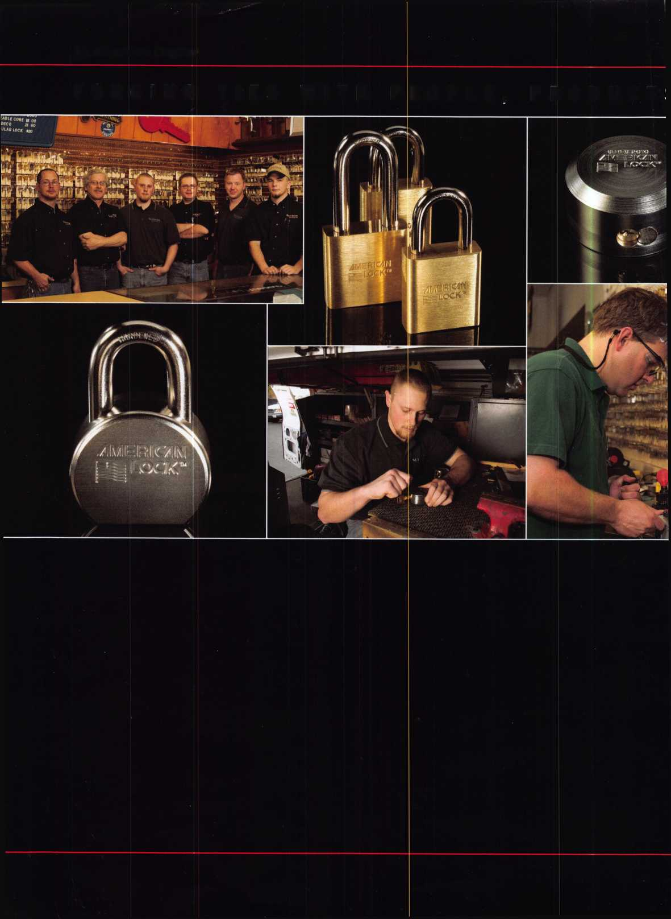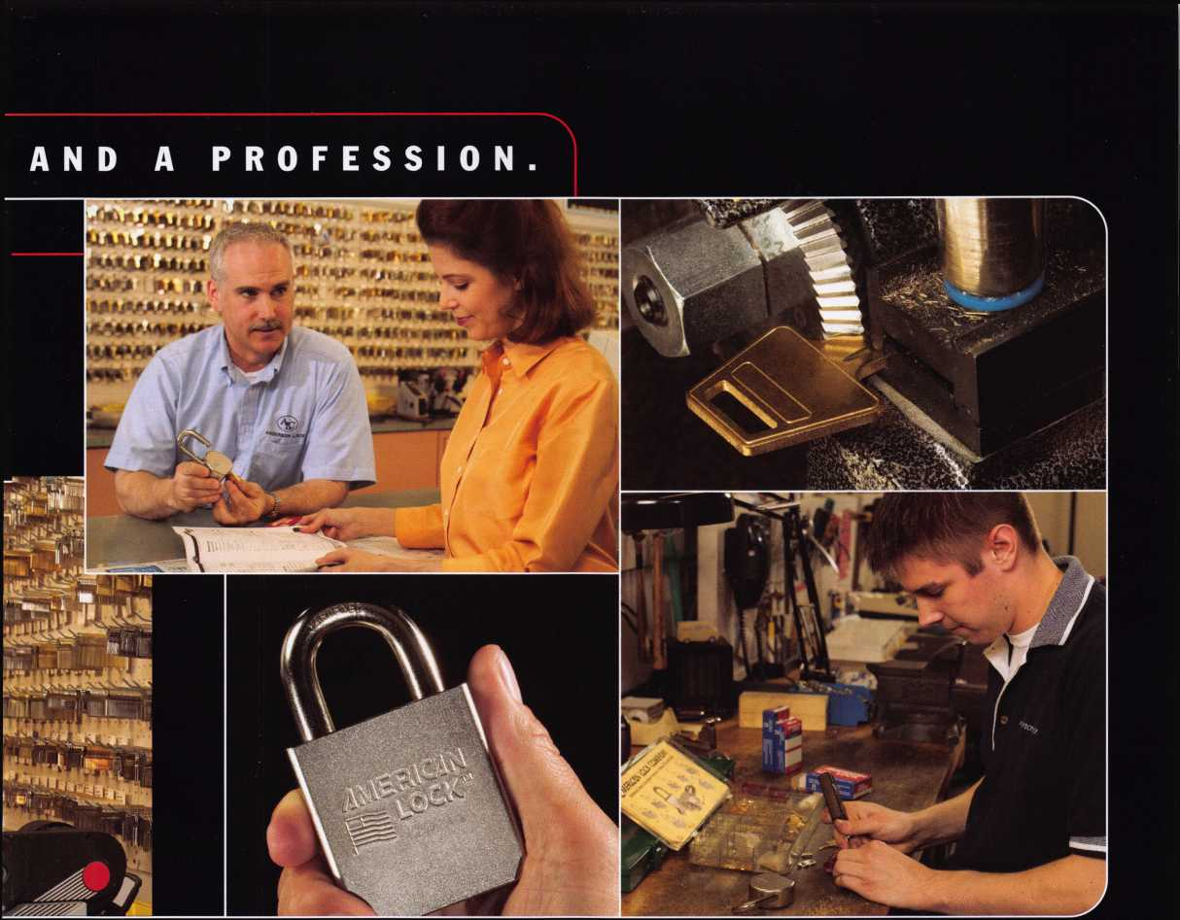

**American Lock and you: a tradition of quality, ingenuity and mutual support.**

For more than 90 years, American Lock has built its reputation with hand-crafted quality and innovations in padlock construction, including numerous "firsts."

* Solid body locks
* Double-ball locking mechanisms
* Serviceable components
* High-security cover plates

.:. and more. All of which firmly established American as the industry's security leader.

**Now American delivers your security needs as never before.**

During the past year American Lock has joined forces with Master Lock, making the industry's strongest offering — led by solid-body American steel, brass and aluminum locks — even stronger. More advantages will arrive in the months ahead.

**See for yourself at ALOA 2004 Security Expo.**

Visit booth 448, where American Lock and Master Lock products will be on display.

Or contact your distributor for details.



© 2004 American Lock Company

|  |  |
| --- | --- |
| preside | n t i a 1 |
| v i e w p o | i n t |

Are all of you aware that ALOA has a Mission Statement? It can be found on the  
Executive page in your Keynotes. I would like to bring to your attention a few sen-  
tences contained in that statement. The first is, "ALOA is dedicated to enhancing the  
professionalism, education and ethics among locksmiths, and those in related sectors  
of the physical security industry." The second is, "But it is only through active  
involvement and participation that ALOA can fully achieve its potential - and help  
members to achieve theirs." This is the focus of the ALOA Board, and we are devel-  
oping ideas and programs to achieve these goals.

One such program that is being developed is the establishing of a Business Owners  
Group. This would be available across the membership, from the one-man operations

to owners of shops with many employees. The purpose would be to provide business and management educa-  
tion to our members and, thus, help them become more astute businessmen. This could be done at convention or  
wherever ALOA education is being conducted. There would also be the opportunity for roundtable discussions at  
convention, whereby owners could break into groups of their peers and discuss issues that affect businesses of  
their size.

We are continuing to develop the idea of ALOA Certified Security Center that was introduced last year at con-  
vention by Hans Mejlshede, CML. This will allow businesses to demonstrate that they meet high standards of pro-  
fessionalism and use that to market and promote themselves against their competition.

One bold idea that has been discussed at our last two meetings is that of requiring new members to become cer-  
tified within a specified amount of time, and that existing members meet continuing education requirements. A  
policy such as this would keep us consistent with our model law for legislation, and legislation for locksmiths that  
currently exists in several states. If licensing requires certification and continuing education, shouldn't we require  
that of ourselves? If our members are certified, that will help us sell ALOA to legislators, manufacturers, service  
providers, etc. We would be an association of certified security professionals. To accomplish this, we realize that  
we have to keep improving our education and the means (technologies) to deliver it to the membership.

I am also pleased to announce that we are closer to being able to offer a corporate" type membership, which  
will make it desirable for locksmith employers to have all of their technicians become ALOA members.

Some of these ideas that may come to fruition will require Bylaws changes. As always, it is in the hands of our  
members to decide what they want and, I am hoping that will mean being the best that we can be. This means  
becoming actively involved!

Thank all of you who expressed concern regarding a safe moving injury that I incurred. My foot is healing well,  
and I was fortunate that it was not serious enough to affect my work.

Sincerely,

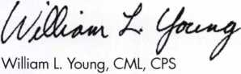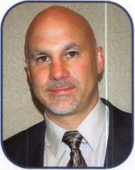

**2**

Keynotes • June 2004

Get ready for ALOA 2004 - the biggest security event in the world! ALOA will land in Baltimore's famed Inner Harbor to stage classes, workshops and exhibits that will help you shine in today's marketplace.

t

*ALObQk*

*get it... together*

The ALOA Convention and Security Expo • Baltimore Convention Center • July 1 9-25, 2004  
(800)532-ALOA(2562) • [convention@aloa.org](mailto:convention@aloa.org) • [www.aloa.org](http://www.aloa.org)



f

e

a

t

u

r e s

MASTER KEYING 2004

12

COVER: The Magic of Spherical Masterkeying,

Part 2

[Editor's Note: Part 1 of this article appeared in November 2003's Keynotes.] Shortly after finishing the six-pin system, I decided that I was pretty much obligat­ed to go ahead and finish what I had started. The daunting task of generating the 1 28 possible key com­binations was, however, more than I wanted to face alone!

**18**

**24**

By Eric Cosfley, CRL

COVER: The ABC's, GMK's, MK's and CK's of Masterkeying (A Beginners Guide)

Of all the tasks we are asked to perform in this profes­sion, probably the one that is the most feared, abused and misunderstood is that of creating a master key sys­tem for a customer. It is feared by some because it pure­ly and simply boils down to mathematics. Well give beginners a better understanding of the workings of a master key system and remove some of the fear.

By Jim Hancock, CRL

AUTOS: 2001 ACURA 3.5RL: FITTING AND CLONING A HONDA TRANSPONDER

There are still too many locksmiths out in the field who are letting the automotive dollars slip away because technology and education seem to be too demanding. They aren't, and this series will aim to help show how simple (and lucrative) next-generation automotive lock- smithing can be. Our subject is a 2001 Acura 3.5RL- chosen for the supposed difficulty in dealing with the Honda system, as referenced by many experts. Let's take a look.

By Jeff Trepanier, RL

**Departments**

|  |  |
| --- | --- |
| Executive 5 | Legislative |
|  | Update 38 |
| Applicants 6 | Classifieds 40 |
|  | Associate |
| Calendar 8 | Members 42 |

**28**



**34**

AUTO: Cycle Chronicles: 100 years of Harley-Davidson, Part 1

In 2003, Harley-Davidson celebrated its 100th anniver­sary. Officially, its legacy begins slowly and humbly at a small Milwaukee Wisconsin shop in 1903 where three young men, Walter Davidson, Arthur Davidson and William S. Harley produced their first motorcycle. Is that what really happened? How did it all really begin?

By Ray D'Adamo, CML

GREG'S CORNER : Book Review: The Safe Technician's Reference Manual (By Mike Oehlert, CPL, CMST)

Our focus is on automotive applications, because the wafer design has always been popular with cars. At this point, virtually all vehicles use wafer locks. The problem we are concerned with is tumblers that either stick or otherwise become nonfunctional. Within the automotive environment, these problems are common. Here's how to solve them.

Reviewed by Greg Perry, CML, CPS

Meet ALOA's Home State Hosts: The Maryland Locksmith Association

The Maryland Locksmith Association (MLA) is proud to host the 2004 ALOA Convention and Trade Show in their home state. Many MIA members live or work just a short distance from the Baltimore Convention Center— the site of this year's show. MIA will have a booth on the ALOA Convention floor. They hope to meet and wel­come all attending the 2004 ALOA Convention.

By Claire Choen, CML

|  |  |  |  |
| --- | --- | --- | --- |
|  | Ad Index |  |  |
|  | A&B Safe | 8 |  |
|  | Adesco | ...23 |  |
|  | American Lock | 1 |  |
|  | Hickok Back Cover | |  |
|  | Hinge Doctor | ...41 |  |
|  | LAB | 7 |  |
|  | Lock Man Tools | 41 |  |
|  | Lockmasters (PUREAuto) | 9 |  |
|  | Professional  Business Products | 9 |  |
|  | Turn 10 | .41 |  |
| L |  |  | J |

Visit our website at [www.aloa.org](http://www.aloa.org)

executive

Volume 50, Issue 6



Additional contact information for the ALOA Board and most Keynotes authors is  
available through "Locks th Search'" on the ALOA Web site- [www.aloa.org](http://www.aloa.org) or by  
contacting the ALOA of at 3003 Live Oak Street; Dallas, TX 75204; (800)532-2562;  
FAX (214)827-1810; e-n il [aloa@aloa.org](mailto:aloa@aloa.org).

|  |  |
| --- | --- |
| Editor  Jim DeSimone | [editor@aloa.org](mailto:editor@aloa.org) |
| Technical Editor  David Lowell, CML, CMST ... | [david@aloa.org](mailto:david@aloa.org) |
| Editorial Advisor  John Cannon, CML | sec reta ry@a loa. o rg |
| Art Director  Betty Henderson | [betty@aloa.org](mailto:betty@aloa.org) |
| Advertising Sales  Kim Hammond | voice: 817-645-6778  Fax: 817-645-7599 e-mail: [adsales@aloa.org](mailto:adsales@aloa.org) |

Executive Director

Charles W. Gibson, Jr., CAE [charlie@aloa.org](mailto:charlie@aloa.org)

Convention & Meetings Manager

Jo Anne Mims [joanne@aloa.org](mailto:joanne@aloa.org)

PRP/Education Manager

David Lowell, CML, CMST ..

Contributors

Jerome Andrews, CML  
Paul Chandler, CRL  
Claire Cohen, CML  
Brian Costley, CML, CMST  
Eric Costley, CRL

[david@aloa.org](mailto:david@aloa.org)

Ray D'Adamo, CML Sal Dulcamaro, CML Billy Edwards, CML Dan Graffeo, CRL,CMST Jim Hancock, CRL

Operations/Membership Manager

Mary May [mary@aloa.org](mailto:mary@aloa.org)

Government Relations Manager

Paul Kanitra [paul@aloa.org](mailto:paul@aloa.org)

IT Operations Manager

Greg Jackson [greg@aloa.org](mailto:greg@aloa.org)

Comptroller Kathy J. Romo

Membership Coordinator Shelly Jett

Convention & Meetings Assistant Karen Lyons

PRP/Education Coordinator Hope Rodriguez

Accounting Coordinator Bryan Dease

Mail Room Coordinator Kevin Wesley

Receptionist Cliff White

A.J. Hoffman, CML Jeff Nunberg, CML, CMST Randy Simpson, CML Robert Stafford, CML Dave Thielen, CML

Greg Perry, CML,CPS Tom Seroogy Charles Stephenson, CPS Dennis Watanabe, CML, CMST

Mission Statement: The Associated Locksmiths of America, Inc. is dedicated to enhancing the professionalism, education and ethics among  
locksmiths and those in related sectors of the physical security industry. With approximately 10,000 members in the United States, Canada and the  
freeworld, ALOA is poised to help members obtain the knowledge, the strength, and the confidence to perform their role in the physical security field  
with pride and dignity. But it is only through active involvement and participation that ALOA can fully achieve its potential—and can help members to  
achieve theirs.

Policies: Keynotes® is the official publication of the Associated Locksmiths of America, Inc. (ALOA). Keynotes® acts as a moderator without approving,  
disapproving, or guaranteeing the validity or accuracy of any data, claim, or opinion appearing under a byline or obtained or quoted from an acknowl-  
edged source. The opinions expressed by the authors do not necessarily reflect the official views of ALOA. Also, appearance of advertisements and  
new products or service information does not constitute an endorsement of products or services featured by the Association. The Association does not  
accept responsibility for the inaccuracy of any data, claim, or opinion appearing in this publication, due to typographical errors on the part of the  
authors, Association staff or its agents.

Editor's Note: This publication is designed to provide accurate and authoritative information in regard to the subject matter covered. It is provided  
and disseminated with the understanding that the publisher is not engaged in rendering legal or other professional services. If legal advice and other  
expert assistance is required, the services of a competent professional should be sought.

Authors' Payment: Payment for eligible submissions to Keynotes will be based on the following criteria: topic, time spent and past contributions. Authors who  
regularly submit to Keynotes® are generally paid a higher rate. The latter is especially true of authors who write to fit specific editorial needs and submit said copy  
by Keynotes® deadlines. As a general guideline: Average payment for a 750 word, business or light' technical article would be $200. Payment for a 1500 word  
article involving significantly higher time and research efforts would be $400.

Payment will not be offered for articles submitted by ALOA employees or members of the ALOA Board of Directors (unless material is of a technical  
nature), nor for articles submitted by a company that promote that company's products or services. ALOA reserves the right not to pay for articles sub-  
mitted by an individual(s) that promote a particular company's products or services.

Disclaimer: The Associated Locksmiths of America, Inc., (ALOA), reserves the right to refuse any article for any reason. Additionally, ALOA reserves  
the right to edit, amend or modify any article submitted for publication in order to preserve technical accuracy, clarity, fairness or grammatical cor-  
rectness. ALOA will make the best efforts to notify the author of any changes. The extent of ALOA's liability for any article or information contained  
therein will be a notice of correction or retraction in the next possible issue.

Keynotes® (ISSN 0277 0792) is published monthly except for the combined June/July issue by The Associated Locksmiths of America, Inc., 3003 Live Oak St., Dallas, TX 75204-6186. Telephone: (214) 827-1701; FAX (214) 827-1810; e-mail [aloa@aloa.org](mailto:aloa@aloa.org). Subscription rates for members—$15.00 per year. Periodical class postage paid at Dallas, Texas. POSTMASTER: Send address changes to: Keynotes, 3003 Live Oak St., Dallas, TX 75204-6186. © Copyright 2003, All rights reserved. No part of the contents may be reproduced or reprinted in any form without prior written permission of the publisher.

President

William L. Young, CML  
(610)647-5042  
[president@aloa.org](mailto:president@aloa.org)

Secretary

John D. Cannon, CMl  
(703) 960-6413  
secretary@aloa .org

Directors/ Northeast

Robert E. Mock

(856) 863-0710  
ned i rector@a loa. org

Peter Sarailian, CRL  
(973)890-9797

ned i rector@a I oa. org

William L. Young, CML  
(610) 647-5042  
nedi rector@aloa. org

Directors, Southeast

Tom Gillingham, Jr., CML, CPS  
(615)264-0747  
[sedirector@aloa.org](mailto:sedirector@aloa.org)

Ken Kupferman, CPL

(813)961-5784  
sedirector@aloa .org

Directors, North Central

Mark E. Blum, CML, CPS  
(517) 482-5809

ned i rector@aloa. org

John Soderland, CML, CMST  
(414) 327-5625  
ned i rector@aloa. org

Director, South Central

CD Lipscomb, CML, CPS  
(903)874-3522  
sedi rector@aloa. org

Directors, Southwest

Gordon R. Racine, CML  
(719) 384-4707  
[swdirector@aloa.org](mailto:swdirector@aloa.org)

Julie McCtuney, CRL  
(714) 636-5652  
swd i recfor@aloa. org

Director, Northwest

Scott L. Henke, CPL, CPS  
(907) 248-3785  
nwd i recfor@aloa. org

Director, European

Hans Mejlshede, CML  
(453)539-3939  
[eurdirector@aloa.org](mailto:eurdirector@aloa.org)

Director, Asian

Joe J. Lee, CRL  
(215)289-2404  
[asiandirector@aloa.org](mailto:asiandirector@aloa.org)

Director, Associate

Paul M. Justen  
(800)333-6953  
asd i rector@aloa. org

Trustees

[trustees@aloa.org](mailto:trustees@aloa.org)

Randy Simpson, CML  
(281)240-5959

JohnJ. Greenan, CML, CPS  
(773) 486.2030

Dallas Brooks  
(334) 826-8990

Past Presidents

2001-2002 Randy Simpson, CML  
1999-2001 John Greenan, CML, CPS  
1997-1999 Dallas C. Brooks  
1995-1997 David Lowell, CML, CMST  
1993-1995 Breck Camp, CML  
1991-1993 Henry Printz, CML  
1989-1991 Evelyn Wersonick, CML, CPS  
1987-1989 Leonard Passarello, CPL  
1985-1987 Joe Jackman, CML  
1983-1985 Stanley Haney, CPL  
1981-1983 Louis LaGreco, CPL  
1979-1981 John Kerr, RL  
1977-1979 Clifford Cox, CML  
1974-1977 Charles Hetherington  
1972-1974 Gene Laughridge  
1970-1972 William Dutcher, RL  
1968-1970 Constant Maffey, RL  
1966-1968 Harold Edelstein, RL  
1964-1966 William Meacham

1962-1964 Robert Rackliffe, CPL 1960-1962 Edwin Toepfer, RL 1956-1960 Ernest Johannesen

\

Keynotes • June 2004

**5**

AK

IL

MT

OH

VA

Anchorage Rockford

Jim Pennington Thad M. Johnson

Sponsor: Scott L Henke CPL, CPS Chelsea M. Spinello

Sponsor: Guy M. Spinello RL

APO

Richard Paternoster

AZ

Gilbert

Dennis Heath

Sponsor: William Lee CRL

CA

Westminster

John Foote

CO

Aurora

Alan B. Collins

FL

Pensacola

Danny C. Brannon

West Palm Beach

Jeff Longer

Sponsor: Robert J. Longer

GA

Atlanta

Kirk T. Viator Marion Davis

Statesboro

Farris Tompkins

Sponsor: William H. Stradling III

HI

Honolulu

Elmer Acob

Sponsor: Daaiyah Gonzalez

Dewey Keaweehu

Sponsor: Daaiyah Gonzalez

Xavier Colon

Sponsor: Daaiyah Gonzalez

ID

McCall

Rick Fereday

IN

Bedford

Christopher K. Morron

Sponsor: John R. Ginger CRL Fairmount

Matthew Trice

KS

Fort Scott

Dan Keenan

Covington

Lawrence A. Wolnitzek

Sponsor: Robert F. Deck CRL Edgewood

Harry E. Smith

Sponsor: Robert F. Deck CRL

MA

Jamaica Plain

Paul H. Cummings

Sponsor: David M. Troiano

MD

Bowie

Gregory Edwards

Davidsonville

Jessica Brennan

Sponsor: Lance A. Edwards Edgewood

Salome Rushdan

Germantown

Joshua A. Higgins

Sponsor: Paul E. Jacobson CPL Kensington

Ernest V. Breazeale

Sponsor: William V. Breazeale CML, CPS

Ml

Grand Rapids

Rodney Riskey

Waterford Township

David Kamber

Sponsor: Thomas J. Lewis CPL

Helena

Jim Mastrangelo

NC

Asheville

Robert Wylie

Sponsor: James Damien CRL Charlotte

Teddy S. Poulos

Sponsor: Robert J. Klinkner Leland

Robert D. Murray Sr

NE

Gibbon

Charles H. Smallcomb

Sponsor: Bernard L Dobesh Kearney

Jerry Caldwell

Sponsor: James L. Hancock CPL

NJ

Manasquan

James P. Downey

Sponsor: Peter Sarailian CRL

Jane Downey

Sponsor: Peter Sarailian CRL

NM

Middleburg Hts

George Petsas

Sponsor: Robert W. Duman Sr, CML Perry

Daniel H. Beal

Sponsor: Clay A. Hart CRL

OK

Norman

Lyndy N. Serpan

OR

McMinnville

James P. Roders

Sponsor: Jody S. Fisher CRL

PA

Charleroi

Charles Yakich

Hanover

Timothy E. Shifflett

Sponsor: Robert L. Channel! Jr; CML Reading

Richard E. Oft

PR

San Juan

Enrique P. Pacheco

Arlington

Heather M. Hurlock

Sponsor: Michael B. Groves Martinsville

Gary McGee

Sponsor: Norman J. Ashley Richmond

Daniel Gholson Steve Cobb

Roanoke

Charles D. Stracke

Sponsor: David M. Frydrych

David G. Hatcher

Sponsor: David M. Frydrych

David A. McCauley

Sponsor: David M. Frydrych

WA

Monroe

Jesse B. Black

Sponsor: Michael D. Tagart

wi

New Lisbon

Reynolds C. Appell

Sponsor: Kenneth W. Briggs

China

Wuxi-City Jiang-Shu

Lizhou Lee

Albuquerque

Brian Romero

Sponsor: William A. Fadgen Jr, CRL

Brandon L. Whitlock

Sponsor: William A. Fadgen Jr, CRL

*sc*

Hanahan

Timothy R. Mincey

Sponsor: Billy E. Fowler

Woodford Green Esse

Mark Franklin

NY

Bay Shore

Alan J. Sobel

Sponsor: Peter Sarailian CRL Bronx

Joseph N. Fludd

Sponsor: David Allen Jr Brooklyn

Menelas Nicolarakis

East Meadow

Michael P. Bach

Sponsor: Robert E. Mock Plainview

Jeffrey Lange

Sponsor: Robert E. Mock

TN

Jackson

Phillip Lacy

Medina

Jeff DeLaney

Sponsor: Tom Gillingham Jr, CML, CPS

Summertown

Rod Ashmore

Sponsor: Ewell M. Jones



Kowloon

Ho Kwong Chor

Sponsor: Kwok-kei Leung

Wai Man Chan

Sponsor: Kwok-kei Leung

Japan

Kyoto City Kyoto

Masayuki Nishikawa

Sponsor: Tomoo Hisano

TX

Cleburne

William N. Bybee

Sponsor: Clifford D. Lipscomb CML, CPS

These applicants are scheduled for clearance as members of ALOA. The names are published for member review and comment within 30 days of this Keynotes issue  
date, respectively, to ensure applicants meet standards of ALOA's Code of Ethics. Protests, if any, should be addressed to the Membership Department and must be  
signed. Active Membership applicants (a) have worked in the industry two or more years. Allied Membership (AL) applicants are not locksmiths, but work in a security-  
related field. Apprentice Membership (AP) applicants have worked in the industry less than two years.

**For Pro**

THE

The Worlds Most Advanced  
Pinning Systems

.261 B.C

**PROVIDING THE SECURITY WORLD WITH QUALITY  
Lock Tumbler Pins, Repinning Kits, Security Tools**

**700 Emmett St., Bristol CT 06010 U.S.A. 1-800-243-8242 FAX 1-860-583-7838  
Website: [www.labpins.com](http://www.labpins.com) E-Mail: [labpins@labpins.com](mailto:labpins@labpins.com)**

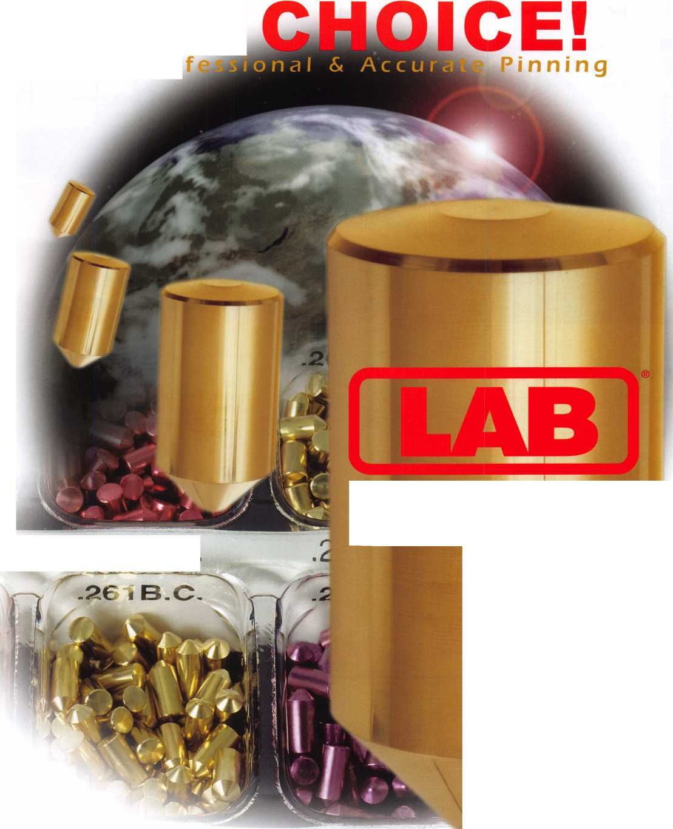

JULY JUNE

upcoming events

6 North Jersey Master Locksmiths Association

1 Oth Annual Flea Market

10-13 International Association of Investigative Locksmiths Educational Conference

13 Southern Lock & Suppply Trade Show St. Petersburg, FL

26 LASA

Safety Deposit Boxes Contact Steve Morse

Quality Inn • Lindhurst, NJ Holiday Inn, Columbia, MD 727-541-5536

Nick Hart: 201 /944-7547 410-674-7721

Phone #512-353-8615 [topnotch@thrifty.net](mailto:topnotch@thrifty.net)

|  |  |  |
| --- | --- | --- |
|  |  |  |
|  | pjgjljjf |  |
|  |  |  |
|  |  |  |

Get it Together!

ALOA Convention and Security Expo July 18-25, 2004 • Baltimore/ MD

**UPCOMING PRP SITTINGS**

|  |  |
| --- | --- |
| 06/06/2004 | 1 1:00am • Albuquerque, NM  Associated Locksmiths of New Mexico  Brian Sweeney, CML 505-266-5577 |
| 6/10/2004 | 8:30am • Dallas, TX • ALOA  Hope Rodriguez 800-532-2562x30 |
| 6/27/2004 | 8:00am • Reno, NV • Clark Security Products  Joan Emrick 619-718-7308 |
| 7/8/2004 | 8:30am • Dallas, TX • ALOA  Hope Rodriguez 800-532-2562x30 |
| 7/23/2004 | 6:00pm • Baltimore, MD • ALOA2004 Convention Hope Rodriguez 800-532-2562x30 |
| 8/12/2004 | 8:30am • Dallas, TX • ALOA  Hope Rodriguez 800-532-2562x30 |
| 9/9/2004 | 8:30am • Dallas, TX • ALOA  Hope Rodriguez 800-532-2562x30 |
| 10/02/2004 | 9:00am • Colorado Springs, CO  Central&Southern CO Locksmith Assn  Gordon Racine, CML 719-384-4707 |

|  |  |
| --- | --- |
| 10/3/2004 | 8:00am • Anaheim, CA • Clark Security Products  Joan Emrick 619-718-7308 |
| 10/9/2004 | 8:00am • Omaha, NE • MINK Convention  Bernard Dobesh 308-381-4440 |
| 10/14/2004 | 8:30am • Dallas, TX • ALOA  Hope Rodriguez 800-532-2562x30 |
| 10/15/2004 | 6:00pm • Portland, OR • Pacific Locksmiths Assn  Dan Cunningham, CRL 360-835-7131 |
| 10/23/2004 | 9:00am • Sturbridge, MA • Yankee Security Convention Jack Hobin 800/209-8266 |
| 10/31/2004 | 10:00am • Mt Laurel, NJ • GPLA  Robert J. Schuetrumpf, CRL 856-486-9280 |
| 11/11/2004 | 8:30am • Dallas, TX • ALOA  Hope Rodriguez 800-532-2562x30 |
| 11/20/2004 | 8:00am • Atlanta, GA • Georgia Chapter of ALOA Kevin Wilson, CML,CPS 770-279-1 161 |
| 12/9/2004 | 8:30am • Dallas, TX • ALOA  Hope Rodriguez 800-532-2562x30 |



**SAFE CORPORATION**

MANUFACTURES OF QUALITY DEPOSITORY SAFES AND CHESTS

DISTRIBUTING FROM WAREHOUSES IN

* LOS ANGLES, CA
* CHICAGO, IL
* GLASSBORO, NJ

A & B is now a stocking distributor

for Mutual Safes

featuring

AB-4-30-3S AB-9-2 WS 10-2

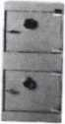

Chose from over 75 models in stock

We ship your order within

24 hours

See us

at [www.a-bsafecorp.com](http://www.a-bsafecorp.com)  
800-253-1267  
Fax 856-863-1208

CALL FOR YOUR  
CATALOG TODAY

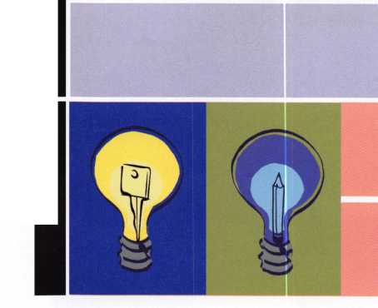

**UPCOMING ACE CLASSES**

6/5/2004

7/18-25/2004

8/22 - 28/2004

9/18/2004

Randolph, MA • The Flying Locksmiths

Barry McMenimon, CRL 781-963-5080

High Security Cylindars with L-08 Prep

Baltimore, MD • ALOA 2004 Annual Convention

DAVID LOWELL, CML, CMST 800-532-2562 XI8 71

ALOA ACE CLASSES and Security Expo

[education@ALOA.org](mailto:education@ALOA.org) 39 Seminars and Half Day Classes

Dallas, Texas • ALOA Continuing Education

8- Day Basic Locksmithing Course

David Lowell, CML, CMST

800-532-2562x18

[education@aloa.org](mailto:education@aloa.org)

Atlanta, GA • Georgia Chapter of ALOA Kevin Wilson, CML, CPS 770-279-1161 PRP Prep Class

10/7-10/2004 Omaha, NE • MINK Convention Bernard Dobesh 308-381-4440 CPS Prep Class [www.nebraska-locksmith.com](http://www.nebraska-locksmith.com)

10/12 - 16/2004 Portland, OR • Pacific Locksmiths Association Tom Jones, CRL 503-842-2944 17 ACE Classes

10/20 - 24/2004 Sturbridge, MA • Yankee Security Convention Jack Hobin 800-209-8266 9 ACE Classes

10/25 - 30/2004 APPLETON, Wl Fox Valley Technical College Jerry Antoon P-920/735-2406 6 Day Basic Locksmithing Course Fox Valley Technical College F-920/735-2414

Advertise with Weatherproof Safety Labels!

Lockout your  
competition

by placing your  
calling card on  
every door you  
service! Keep

your name in front  
of every customer  
with these Durable,  
Affordable Labels  
Call & Order Today  
1-800-355-6322

(Actual Label Size 1 1/2x4 1/2)

Professional Business Products

ALOA Associate Member

Check out our competitive prices on Invoices with two color ALOA  
logo, Repair Tags/Claim Checks, Business Cards, Door Hangers,  
Shirts, Hats, Pens, Key Tags, Magnets.

ivww.pbp2000.com

and NASCAR

Lockmasters' PUREAuto  
Automotive Weekends  
is proud to addj|,  
NASCAR Race Package  
to t>ur **October Pit Stdp**this year.

2004 Pit StopsN

May 22-2f - Buffalo, NY  
0|t. 1-3 - Talladega, AL  
Nov. 6-7 - Las Vegas, NV

learn From The Industry Experts

Track 1 - Domestic Automotive  
Track 2 - Import Automotive  
Track 3 - High Security Automotive  
Track 4 - Automotive Transponders  
Track 5 - Key Generation  
Track 6 - Mechanical Safe Lock  
Track 7 - Electronic Safe Lock

Check out pureauto.com for  
complete track info & a  
registration form. Register  
early for discounts and assure  
your seat before they sell out.

800.654.0637

pureauto.com

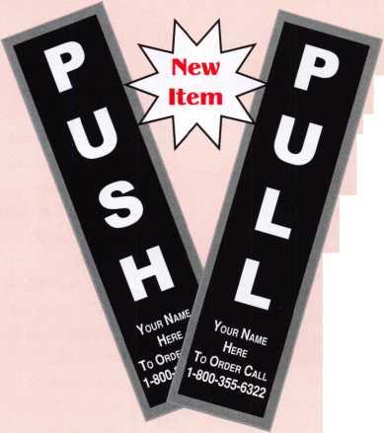

411.04* 100*1 PUQOKft-fkN

aN'8"25’^

Come to  
Baltimore and  
invest in your  
future as a secu-  
rity professional.  
Discover class-  
es, workshops  
and exhibits that

will keep you competetive in  
today’s marketplace.

fc-ftl-T 1W0RE,

get it... together

|  |  |  |
| --- | --- | --- |
| ACCREDITED | ADRIAN | DIPLOMAT |
| + LOCK | STEEL | SAFE |
| SUPPLY | CO. | LTD. |
| 155 | 154 | 255 |
|  | ALL 5 | mUSON SATE |
| LECTRO- | LOCK | COMPANY |
| TRUCK- | 152 | 253 |
| IMS INC. | OLYMPUS  LOCKCa | HIGH |
| 151 | 150 | TECH |
|  | ZIPF LOCK | TOOLS |
|  | LU,  148 | 249 |

|  |  |  |  |  |  |
| --- | --- | --- | --- | --- | --- |
| IRAKPRO  256 | 09 SECURITY  DEUCES  357 | MBA  USA  INC.  354 | AKRON  HARDWARE  455 | | THE  NATIONAL LOCKSMITH 454 I |
| VOICE  ALERT  254 | STONE ft BERG WHOLESALE  355 |
|  | BLACKHANK |  |  |  |  |
|  | PRODUCTS |  |  |  |  |
| 252 | 353 |  |  |  |  |
|  | AUTO | STRATTEC | |  | MASTER |
| PRO-LOK. | SECURITY | SECURITY | |  | LOCK |
|  | PRODUCTS | CORP. | |  | COMPANY |
| 248 | 349 | 348 |  |  | 448 |

RA-LOCK  
CQ

ELSAFE

141

|  |  |  |
| --- | --- | --- |
| HES | LU | SECURITRON  MAGNALOCK |
| INC. | INC. _l | CORP. |
| 142 | 243 22 | 242 |

ARROW S LOCK ^=1

137

YSG DOOR SECURITY CONSULTANTS! 136

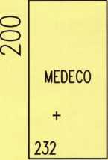

|  |  |  |
| --- | --- | --- |
|  |  | IR SECURITY |
| LU SARGENT —1 MFG. OO COMPANY | SARGENT lu & —1  GREENLEAF 00  inc. :< | &  SAFETY  442 |
| <C |  |
| 340 | 441 |  |
| O ABLOY O DOOR ^SECURITY 336 | SECURITY o LOCK o DIS1RBUT0RS^|-  437 | IR SECURITY & |
| MUL-T- LOCK USA INC. | SECURITY  DISTRBUTORS  INC. | SAFETY |
| 332 | 433 | 432 |

Exhibitors (as of May 17, 2004)

1-800-LOCKSMITH 817

1st In Hardware, Inc 1114

A & B Safe Corporation 725

A & S Enterprises 855

A-l Security Mfg. Corp 1049

Aable Locksmiths 1129

Abloy Door Security 336

Abus Lock Company 748

Accredited Lock Supply 155

A.D. USA 1015

Adams Rite Mfg. Company 633

Adesco Safe Mfg. Company / Star Safe

and Alarm 929

ADI, Inc 827

Adrian Steel Company 154

Akron Hardware 455

Alarm Lock

Systems, Inc. - Napco 643

All 5 Lock 152

Allstate Insurance Company 1040

ALOA

American Eagle Lock Co 852

American Security Products 1132

Armadillo Firearm

Security Products 252

Arrow Lock.. 137

ASSA Inc 243

Auto Security Products 349

Bad Dog Tools. 1228

Bianchi USA, Inc 1236

Blackhawk Products 353

Blades Industries 1121

Booil Safes Co., Ltd 1014

Burg-Wachter 1048

BWD Lockcraft 1120

Camden Door Controls 554

CCL Security Products 927

Clark Security Products 826

Clear Star Security Network 1241

Commercial Van Interiors 719

Compx Security Products 548

Corporate Safe Specialists 1214

D & D Technologies 954

Defiant Safe Co. /ARFE 655

DETEX Corporation 654

Diplomat Safe Ltd 255

DiscountKeyMachines.Com/

Busch Jeff Busch 1123

Don-Jo Manufacturing Inc 1038

Doorking 1239

Dorma Architectural Hardware 1126

Dugmore and Duncan, Inc 755

Eclipse Ind 256

Elsafe 141

ESP Lock Products Inc 1240

Eujin Formula Co, Ltd 1125

FKI Security Group 932

H.LFIake 1254

Framon Mfg. Company, Inc 1139

Gardall Safe Corporation 754

Gentleman Door Company 1127

GMS Industries. 1023

Hammerhead Industries 1249

Hardware Merchandisers, Inc 1056

Hayman Safe Company 556

Hengshui Honyun Industrial 1024

HES, Inc 142

High Tech Tools 249

Homeowners Marketing Services . 716

Howard Keys 1033

HPC, Inc 648

Hurd Corporation 1146

IDN Corporation 926

Inkas Safe Mfg 1218

Innovative Concepts Engineering 723

International Electronics Inc 1155

IR Security & Safety 432, 442, 532

JLM Wholesale 1245

Jet Hardware Mfg.co 726

Kaba llco/Kaba Mas 742,842,942

Keedex Manufacturing 720

Keri Systems, Inc 714

Key-Bak 1217

Klassy Keys, Inc 1137

KSP 1036

Kwikset (formerly BDHHI) 1020

La Gard Inc 1148

LAB Security 1037

Lectro-Truck - IMS, Inc 151

Lockmasters, Inc 636

Locksmith Ledger International 822

Lucky Line Products, Inc 851

MAG Eng. & Mfg 848

Major Manufacturing, Inc 1143

Main's Lock Supply 924

Markar Products Inc 1042

MARKS, U.S.A 821

Master Lock Company 448

MBA-USA, Inc 354

MDS Incorporated 733

Medeco 232

Midwest Wholesale Hardware 1032

MMF Industries 1021

Monaco Lock Company 950

Mul-T-Lock USA, Inc 332

Mutual Safe Company, Inc 823

National Auto Lock 1017

Newell Security Co., Ltd 1135

Olympus Lock Company 457

OSI Security Devices 357

PDQ Manufacturing 857

Perma-Vault Safe Co 856

Peterson Manufacturing 1154

Phoenix Safe International 1025

PowerMate/LP International 917

PRO-LOK 248

Professional Business Products 854

RA-Lock Co 143

Rodman & Company 1028

ROFU International Corp 948

Rutherford Controls Inc.—RCI 1029

SAVTA 815

SNA, Inc 1222

S.E.R.L.A.C 814

Sargent & Greenleaf, Inc 441

SARGENT Manufacturing

Company 340

Schliessanlagen Gmbh Pfaffenhain

Jens Herrmann 1224

Schwab Corp 936

Scorpion CX-5... 1116

Securitech Group, Inc 1133

Securitron Magnalock Corp 242

Security Distributors Inc 433

Security Door Controls 849

Security Lock Distributors 437

Select Products Limited 1054

Shin-An Enterprise, Inc 1115

Song 13 Punch Tool 820

Southern Lock and Supply Co 1138

Southwest Specialty Products 925

Speedypik 920

Stone & Berg Wholesale 355

STRATTEC Security Corp 348

Strong Arm Security, Inc 632

Sun Safes Mfg 1251

Supra Products, Inc 921

The National Locksmith 454

TimeMaster, Inc 722

Townsteel Incorporated 1026

Transponder Innovations 1013

TRAKPRO, LLC 256

Turn 10 Wholesale 1140

U.S. Lock Corp 637

Ultra Lift 955

Victor e-lok 816

Videx 949

Voice Alert 254

Wilson Safe Company 253

Yale Security Group, Inc 136

Zipf Lock Co 148

|  |  |  |
| --- | --- | --- |
| ur  CWANY  556 | DEFIANT  SAFE CO | DETEX |
| CAMDEN D00F CONTROLS | /arte' | CORP. |
| 554 | 655 | 654 |



OUGUORE

AND

IDUNCAN INC.

755

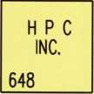

GARDALL

SAFE

CORP.

754

A*S

(ENTERPRISES

855

ABUS

LOCK

COMPANY

748

POO

ira

857

LUCKY

LINE

PRODUCTS

INC.

851

SECURITY  
DOW CONTROLS

849

VAULT

—'ANY

*M.*



AMERICAN EAGLE LOCK

852

MAG ENG.

k

MEG. '

848

|  |  |  |  |  |  |
| --- | --- | --- | --- | --- | --- |
|  |  | HARDWARE |  |  |  |
| ULTRA  LIFT | D&D  TECHNOLOGIES | MERCK  1056 | INT’L  ELECTRONICS | PETERSON  mTacturing | HL  FLAKE |
|  | INC. |
| 955 | 954 | 1Q54_ | 1155 | 1154 | 1255 |

953

VIDEX

949

|  |  |  |  |  |
| --- | --- | --- | --- | --- |
| MONACO |  |  |  | SUN |
| LOCK CO,  950 | A-1  SECURITY  MFG. CORP. | BURG-  WACHTER | LAGARD  INC. | SAFES  1251 |
| ROFU  Wl CORP, | HAMMERHEAD  NDUSTRES |
| 948 | 1049 | 1048 | 1148 | 1249 |

HL

FLAKE +

1254

u

_l

n

*£*

Z> I R

^SECURITY

> &  
SAFETY

_532.

ALARM LOCK  
SYSTEMS  
INC.

643

u.s

LOCK

CORP.

|  |  |  |  |  |
| --- | --- | --- | --- | --- |
| KABA IICO/ | CO  <c | KABA IICO/ |  | KABA IICO/ |
| KABA MAS |  | KABA MAS | UJ 1 | KABA MAS |
| NO | o | 842 | OO | 942 |

|  |  |  |
| --- | --- | --- |
| 637 | 636 |  |
| ADAMS RIIE  MEG |  |  |
| COMPANY | STRONG ARM | NDS |
| SECURITY INC | MC0RP0RA1ED |
| 633 | 652 | 733 |

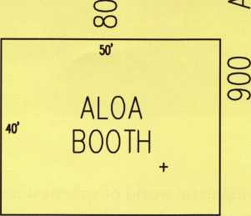

, MARKAR  
L-H PRODUCTS

oo K^ 1042

<C

ALLSTATE  
INSURANCE COj

1040

|  |  |
| --- | --- |
| SCHWAB | LAB |
| CORP. | SECURITY |
| 936 | 1037 |
| FKI | HOWARD |
| SECURITY | KEYS |
| GROUP |
| 932 | 1033 |

_ DON-JO  
O MFC, INC,

O J058_  
2 K S P  
1036

FRAMONMFG

COMPANY

INC.

MIDWEST

WHOLESALE

HARDWARE

1032

MAJOR .

MFG.

INC. ^

HORO

CORPORATION

1146

TURN 10 WHOLESALE

1139

O

O

1140

-JWf

1138

JLM

WHOLESALE

1245

CLEARSTAR

1241

ESP LOCK PRODUCTS

1240

KLASSY

KEYS

1137

NEWIi

SECURITY

1135

SECURIIECH GROUP NG

1133

D00RKNC ,—. T

PONT <3>

1239 O BIANCHI ■^"CNJ USA

1236



A A B SATE

CORP.

Z25_

•M0VAINE

CONCEPTS

1723

707

705

703

COMMERCIAL

VAN

INTERIORS

719

|  |  |
| --- | --- |
| w | 1-800  LOCKSMITH  817 |
| KERI  SYSTEMS  714 | SAVTA  815 |
| 712 | 813 |
| 710 | 811 |
| 708 | 809 |
| 706 | 807 |
| 704 | 805 |
| 700 | 802 |

|  |  |  |  |
| --- | --- | --- | --- |
| JET  HARDWARE MFG. CO.  726 | * n | CLARK  V SECURITY  u PRODUCTS  827 826 | ADESCOSAFE fG CD/SIAR  929 l D N | RUTHERFORD CONTROLS MC.  1029 |
| (XL SECURITY CORP.  PRODUCTS  927 926 | PHOENIX  SATE  INT’L  1025 |
| TIME-  MASTER  INC.  722 | MUTUAL LOCKSMITH  SAFE LEDGER  CO. INC. INT’L  823 822 | &W SPECIALTY MAUI’S LOCK  PRODUCTS SUPPLY  925 924 |
| SUPRA  PRODUCTS SPEEDYPIK  INC.  921 920 | CMS  INOUSTRCS  1025 |
| KEEDEX  MFC,  720 | MARKS SONG 13  U.S.A, PUNCH TOOL  821 820 | 1021 |

801

|  |  |
| --- | --- |
| VICTOR  E-LOK | POWRNA1E/  iMITDlUnflfcUl |
| 816 |  |
| SE.R.LAC.  814 | 915 |
| 812 | 913 |
| 810 | 911 |
| 808 | 909 |
| 806 | 907 |
| 804 | 905 |
| 1 800 |  |

901

900

1001

|  |  |
| --- | --- |
| RODMAN & COMPANY  1028 | AA8LE  LOCKSMITHS  1129 |
| tomnstVel  MCORP. | "X |
| 1026 | 112/ |
|  | EUJN |
| lOUS TRIAL CO | FORMULA |
| 1024 | 1125 |
| KWIKSET  CORP, | BLADES |
|  | INDUSTRIES |
| 1020 | 1121 |

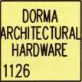

BAD COG  
TOOLS

1228

BMD  
LOCKCRAFT

1120



1223

SNA INC. 1222.1

1221

INKAS

SAFE

1218

|  |  |  |  |  |  |  |
| --- | --- | --- | --- | --- | --- | --- |
| 916 | naYl auto  LOCK  1017 | BOOIL  SAFES | <HN-AN  ENTERPRISES | SCORPION  cx-5  1116 | KEY-BAK  1217 | CORPORATE  SAFE  SPECIALISTS  1214 |
| 914 | ,1 | CO.  1014 | 1115 | 1st N HARDWARE  1114 | 1215 |
| 912 | TRANSPONDER  ^NOVATIONS  1015 | 1012' | '1113 | 1112 | 1213 | 1212 |
| 910 | 1011 | 1010 | 1111 | 1110 | 1211 | 1210 |
| 908 | 1009 | 1008 | 1109 | 1108 | 1209 | 1208 |
| 906 | 1007 | 1006 | 1107 | 1106 | 1207 | 1206 |
| 904 | 1005 | 1004 | 1105 | 1104 | 1205 | =F  1204 |

1000 1102 1101 1100

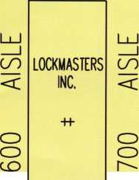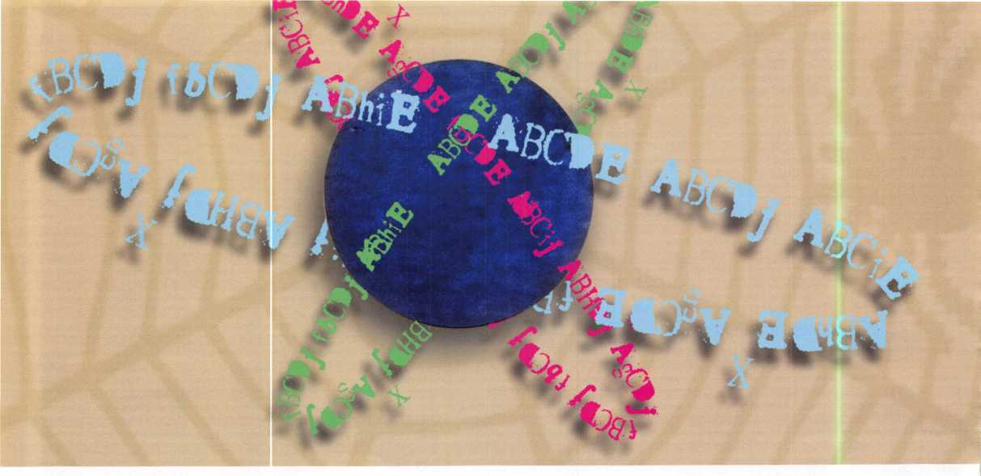

Here we are again, venturing into the interesting and enigmatic world of spherical masterkeying. For the sake of those who might be interested in using the sphere in an interchangeable core application, I have enlisted some mathematical help and completed the seven-pin matrix and listing. Shortly after finishing the six-pin sys­tem, I decided that I was pretty much obligated to go ahead and finish what I had started. The daunting task of generating the 128 possible key combinations was, however, more than I wanted to face alone!

I put in a call to Perry Price, one of my classmates from Gardner-Webb University (Boiling Springs, NC). Perry was a math major there, and then went on to get his Master’s Degree from the University of North Carolina at Pembroke. I was sure that once he understood what I was trying to achieve, it would be a simple task for him. He was sure of it also, and despite the fact that Perry knew nothing of master keying, he promised to fax me a list of the 128 combinations.

It would seem that generating the 128 combinations proved a daunting task for even the most savvy mathe­matician that I know, and that frightened me somewhat. If he was in over his head, I knew I was in way over mine! Perry was, however, quick to realize that the patterns that emerge when generating a spherical system fit nicely into Pascal’s triangle — something I knew nothing of, but I can give you a faint glimmer of what it’s all about.

Blaise Pascal lived from 1623 to 1662. He was a mathematician, physicist, and theologian. His father was a tax collector, and he managed to devise a mechanical calculator capable of addition to help his father out. Some of you may recall that there is a computer program named after Pascal. Although the groupings of keys in spher-

The Magic of Spherical Master Keying Part 2

By Eric Costley, CRL

{Editor’s Note: Part i of this article appeared in November 2003’s Keynotes.}

**2**

Keynotes • June 2004

Key 1. Key 1 only

Key 2. Keys 1 and 2

Key 3. Keys 1 and 3

Key 4. Keys 1 and 4

Key 5. Keys 1 and 5

Key 6. Keys 1 and 6

Key 7. Keys 1 and 7

Key 8. Keys 1 and 8

Key 9. Keys 1,2,3,9

Key 10. Keys 1,2,4,10

Key 11. Keys 1,2,5,11

Key 12. Keys 1,2,6,12

Key 13. Keys 1,2,7,13

Key 14. Keys 1,2,8,14

Key 15. Keys 1,3,4,15

Key 16. Keys 1,3,5,16

Key 17. Keys 1,3,6,17

Key 18. Keys 1,3,7,18

Key 19. Keys 1,3,8,19

Key 20. Keys 1,4,5,20

Key 21. Keys 1,4,6,21

Key 22. Keys 1,4,7,22

Key 23. Keys 1,4,8,23

Key 24. Keys 1,5,6,24

Key 25. Keys 1,5,7,25

Key 26. Keys 1,5,8,26

Key 27. Keys 1,6,7,27

Key 28. Keys 1,6,8,28

Key 29. Keys 1,7,8,29

Key 30. Keys 1,2,3,4,9,10,15,30

Key 31. Keys 1,2,3,5,9,11,16,31

Key 32. Keys 1,2,3,6,9,12,17,32

Key 33. Keys 1,2,3,7,9,13,18,33

Key 34. Keys 1,2,3,8,9,14,19,34

Key 35. Keys 1,3,4,5,15,16,20,35

Key 36. Keys 1,3,4,6,15,17,21,36

Key 37. Keys 1,3,4,7,15,18,22,37

Key 38. Keys 1,3,4,8,15,19,23,38

Key 39. Keys 1,4,5,6,20,21,24,39

Key 40. Keys 1,4,5,7,20,22,25,40

Key 41. Keys 1,4,5,8,20,23,26,41

Key 42. Keys 1,5,6,7,24,25,27,42

Key 43. Keys 1,5,6,8,24,26,28,43

Key 44. Keys 1,6,7,8,27,28,29,44

Key 45. Keys 1,5,7,8,25,26,29,45

Key 46. Keys 1,4,7,8,22,23,29,46

Key 47. Keys 1,3,7,8,18,19,29,47

Key 48. Keys 1,2,7,8,13,14,29,48

Key 49. Keys 1,4,6,7,21,22,27,49

Key 50. Keys 1,3,6,7,17,18,27,50

Key 51. Keys 1,2,6,7,12,13,27,51

Key 52. Keys 1,3,5,6,16,17,24,52

Key 53. Keys 1,2,5,6,11,12,24,53

Key 54. Keys 1,2,4,5,10,11,20,54

Key 55. Keys 1,2,4,6,10,12,21,55

Key 56. Keys 1,2,5,7,11,13,25,56

Key 57. Keys 1,3,5,7,16,18,25,57

Key 58. Keys 1,2,4,7,10,13,22,58

Key 59. Keys 1,2,5,8,11,14,26,59

Key 60. Keys 1,3,5,8,16,19,26,60

cylinder pinned to key 1 and the numbered key: Is operated by the

following

Key 61. Keys 1,3,6,8,17,19,28,61 Key 62. Keys 1,2,6,8,12,14,28,62 Key 63. Keys 1,4,6,8,21,23,28,63 Key 64. Keys 1,2,4,8,10,14,23,64 Key 65. Keys

1. Key 66. Keys
2. Key 67. Keys
3. Key 68. Keys
4. Key 69. Keys
5. Key 70. Keys
6. Key 71. Keys
7. Key 72. Keys
8. Key 73. Keys
9. Key 74. Keys

1,2,3,6,7,9,12,13,17,18,27,32,33,50,51,74 Key 75. Keys

1. Key 76. Keys
2. Key 77. Keys
3. Key 78. Keys
4. Key 79. Keys
5. Key 80. Keys
6. Key 81. Keys
7. Key 82. Keys
8. Key 83. Keys
9. Key 84. Keys

1,2,3,6,8,9,12,14,17,19,28,32,34,61,62,84 Key 85. Keys

1. Key 86. Keys
2. Key 87. Keys

1,2,3,7,8,9,13,14,18,19,29,33,34,47,48,87 Key 88. Keys

1. Key 89. Keys
2. Key 90. Keys
3. Key 91. Keys
4. Key 92. Keys

1.5.6.7.8.24.25.26.27.28.29.42.43.44.45.92

keys:

Key 93. Keys

1. Key 94. Keys
2. Key 95. Keys
3. Key 96. Keys
4. Key 97. Keys
5. Key 98. Keys
6. Key 99. Keys
7. Key 100. Keys

1.2.3.4.5.6.9.10.11.12.15.16.17.20.21.24.30.31,

1. Key 101. Keys

1.2.3.4.5.7.9.10.11.13.15.16.18.20.22.25.30.31,

1. Key 102. Keys

1.2.3.4.6.7.9.10.12.13.15.17.18.21.22.27.30.32,

1. Key 103. Keys

1.2.3.5.6.7.9.11.12.13.16.17.18.24.25.27.31.32,

1. Key 104. Keys

1.2.4.5.6.7.10.11.12.13.20.21.22.24.25.27.39.40,

1. Key 105. Keys

1.3.4.5.6.7.15.16.17.18.20.21.22.24.25.27.35.36,

1. Key 106. Keys

1.2.3.4.5.8.9.10.11.14.15.16.19.20.23.26.30.31,

1. Key 107. Keys

1.2.3.4.6.8.9.10.12.14.15.17.19.21.23.28.30.32,

1. Key 108. Keys

1.2.3.5.6.8.9.11.12.14.16.17.19.24.26.28.31.32,

1. Key 109. Keys

1.2.4.5.6.8.10.11.12.14.20.21.23.24.26.28.39.41,

1. Key 110. Keys

1.3.4.5.6.8.15.16.17.19.20.21.23.24.26.28.35.36,

1. Key 111. Keys

1.2.3.4.7.8.9.10.13.14.15.18.19.22.23.29.30.33,

1. Key 112. Keys

1.2.3.5.7.8.9.11.13.14.16.18.19.25.26.29.31.33,

1. Key 113. Keys

1.2.4.5.7.8.10.11.13.14.20.22.23.25.26.29.40.41,

1. Key 114. Keys

1.3.4.5.7.8.15.16.18.19.20.22.23.25.26.29.35.37,

1. Key 115. Keys

1.2.3.6.7.8.9.12.13.14.17.18.19.27.28.29.32.33,

1. Key 116. Keys

1,2,4,6,7,8,10,12,13,14,21,22,23,27,28,29,44,46,

1. Key 117. Keys

1,3,4,6,7,8,15,17,18,19,21,22,23,27,28,29,36,37,

1. Key 118. Keys

1.2.5.6.7.8.11.12.13.14.24.25.26.27.28.29.42.43,

1. Key 119. Keys

1.3.5.6.7.8.16.17.18.19.24.25.26.27.28.29.42.43,

1. Key 120. Keys

1,4,5,6,7,8,20,21,22,23,24,25,26,27,28,29,39,40,

1. Key 121. Keys

1.2.3.4.5.6.7.9.10.11.12.13.15.16.17.18.20.21.22,

1. 51,52,53,54,55,56,57,58,65,66,67,68,69,70,71,72, 73,74,75,76,77,78,79,100,101,102,103,104,

105.121

Key 122. Keys

1. 24,26,28,30,31,32,34,35,36,38,39,41,43,52,53,
2. 83,84,85,86,95,97,99,100,106,107,108,109,

110.122

Key 123. Keys

1. 25,26,29,30,31,33,34,35,37,38,40,41,45,46,47,
2. 83,87,88,89,94,96,98,101,106,111,112,113,

114.123

Key 124. Keys

1,2,3,4,6,7,8,9,10,12,13,14,15,17,18,19,21,22,23

,27,28,29,30,32,33,34,36,37,38,44,46,47,48,49,

50.51.55.58.61.62.63.64.66.70.74.75.76.80.84.85,

86.87.88.89.90.91.93.102.107.111.115.116,

117.124

Key 125. Keys

1,2,3,5,6,7,8,9,11,12,13,14,16,17,18,19,24,25,26 ,27,28,29,31,32,33,34,42,43,44,45,47,48,50,51, 52,53,56,57,59,60,61,62,67,71,74,77,78,81,84,87, 90,91,92,96,97,98,99,103,108,112,115,118,

119.125

Key 126. Keys

1.2.4.5.6.7.8.10.11.12.13.14.20.21.22.23.24.25,

26.27.28.29.39.40.41.42.43.44.45.46.48.49.51,

53.54.55.56.58.59.62.63.64.68.72.75.77.79.82.85,

1. 118,120,126

Key 127. Keys

1. 26,27,28,29,35,36,37,38,39,40,41,42,43,44,45,

46.47.49.50.52.57.60.61.63.69.73.76.78.79.83.86,

1. 119,120,127

Key 128. Operated by all keys within the system

Keynotes • June 2004



ical keying relate directly to Pascal’s triangle, my knowledge of math doesn’t extend that far! If any of you are really interested in the mathematical basis for all this, I suggest that you fire up your computer and type Pascal’s triangle into your favorite search engine; there is ample information out there to whet the appetite of even the most mathematical mind!

Meanwhile, my customers kept asking for exotic cross keying in their master key systems, and my familiarity with the ins and outs of the spherical system became more clear as I tried to implement it.

There are a lot of quirks with trying to implement a spherical system, and the greatest of these is the severe limitation of individual change keys. Do this by counting the number of change keys needed and not­ing the size of the largest grouping of keys available in the sphere you are using.

A five-pin system of 32 keys yields the following groupings of keys: 1,5,10,10,5,1. The largest grouping here is 10 keys. If you need more than 10 independent change keys, the sphere will not accommodate your customer’s needs! A six-pin system yields 64 combina­tions, grouped as follows: 1,6,15,20,15,6,1. If you need more than 20 individual change keys, you are once again out of luck. The seven-pin system will allow you a whopping 128 keys, but the largest group of inde­pendent change keys you can use here is merely 35! A seven-pin system falls into the following hierarchy: 1,7,21,35,35,21,7,1.

Confused yet? Join the crowd! Even so, I have delved further into the sphere. For the sake of those who are totally confused, I will digress a bit.

For every master wafer we add to a cylinder, we add keys that will operate that cylinder exponentially. One master wafer creates two keys. Two master wafers cre­ates four potential keys, and so forth. With five mas­ter wafers, we create 32 potential keys that will oper­ate the cylinder. However, the choice of the keys that are actually implemented into the system is just as important as the pinning of any individual cylinder.

One of the big “flaws” of master keying is that many of us rely on some computer-generated system to design our final product. Unless you actually under­stand the concept of master keying initially, all of this

will wash over you as just another “technical article” in one of the trade magazines. Since I have been getting lots of questions on spherical master keying,

I know that many of you are actually beginning to catch on.

Every master key system that you implement is an icon unto itself, and every customer you satisfy is another feather in your cap. The end user of any given system has no clue of how intense their particular sys­tem may be, or how many sleepless nights you spent designing it; all they know is you either did or did not manage to do exactly what they initially requested. If you did not, they are likely to go somewhere else next time, no matter how many times you try to reiterate that what they have requested is outrageous.

The Sphere is simple in theory. In any given pin posi­tion, you have only two variables, either the master key cut, or the change key cut. It is a very limited rotating constant system, and those limitations can be an asset, as we will see later on.

Back to the heart of the matter: In a five-pin system, you are limited to 10 autonomous change keys. In a six-pin system, that doubles to 20. In a seven-pin sys­tem, that expands to 35 change keys. However, the beauty of the system lies in the ability to pin cylinders to a variety of keys that may or may not actually exist in the final system.

Here again I must jump on my high horse and degrade most of the existing master keying software. A com­puter that spits out change keys and pinning charts does not help you; it limits you. Relying on such soft­ware exclusively tends to make the brain lazy, and the actual theory behind what you accomplish is not nec­essary when you simply punch numbers into a comput­er program. If you realize that pinning a cylinder with three master wafers will accommodate eight individual keys that operate that cylinder, (even if only two or three of those keys are actually used in the final sys­tem), you are smarter than any computer program.

If I come off as arrogant, it is certainly unintentional. What I do know is that what the customer wants and what you can actually do mathematically are often two different things. What the Sphere accomplishes is an alternative that might make your life a little easi­er, and your customer’s system a little more secure.

**14**

Keynotes • June 2004

The Sandwich

Here’s the really exciting part of the Sphere: It is not a stand alone system! A spherical system can be “sand­wiched” into a classical system, if you plan ahead! (If you’re lost already, raise your hand. My number is in the book, and my employers have been patient so far.) In a standard classical master key system, the master key cuts never appear in any of the change keys.

If you go ahead and generate your standard keying matrix, your results might resemble something like this:

GMK: 147945

bitting array: 369167

581389

03501

925723

If you want to make a sandwich while you’re reading this, make sure you don’t get mustard on the pages; it might make coming back to this difficult when a cus­tomer is depending on you! I am about to make a sandwich myself -- by plugging a sphere into this clas­sical full position progression system! Let’s go into our existing bitting array and eliminate the following possi­bilities, from left to right: 561503. This is a six-pin sys­tem, so the positions that we have eliminated from our system are now our 64th key in our sphere. Now that these possibilities are gone, there is no possibility of interchange with our classical system, and our master key will still work in both of our co-existing systems!

This will limit the size of the classical end of your master key system, but it also allows you to do some extensive cross keying without stacking master wafers in a single pin chamber. Unless you are working on a large industrial system, it is unlikely that you would ever use the myriad of change keys generated by a full-blown classical system anyway. Once you have substituted actual key bittings for the letters in the Sphere listing, all that remains is to pick from the list­ing of “what fits what” to accommodate your cus­tomer’s requirements. This can be time consuming and often confusing, but the results are very gratify­ing. Once you’ve decided exactly what the needs of the system are, start looking in the “lower levels” for

your extensively cross-keyed doors, and then pick your keys that operate those doors from the higher levels of the Sphere. It takes a bit of practice, but after a few times, you will find that it becomes easier.

For those of you who might be wondering, no this is not just some theory that I dreamed up while I stared lazily out of my window on a summer day I developed this system pretty much by accident as I attempted to fulfill my clients’ diverse needs in some rather intricate systems. As I publish this, these systems have actually been physically implemented in a few locations, and I have yet to have problems or complaints from my cus­tomers. As they say, “The proof is in the pudding,” and evidently, this is some pretty good pudding.

Initially, I never intended to go beyond the five-pin sphere. However, a phone call from Hank Tennenbaum, CRL, with Precision Door in Alexandria, VA, changed my mind. Hank had read the initial article, (see the November 2003 issue of Keynotes,) and called before I ever saw my article in print! He was struggling with a customer who was switching from an Abloy rotating disc system to a Primus six-pin system. The elaborate keying that was possible with Abloy does not translate well into a standard pin tumbler lock, and yet the customer wanted basically the same exotic master keying and cross keying. Once I looked at the maze of cross keys needed, I decided to try to take Spherical keying to the next level in order to help Hank. Problem is, how­ever, that the Sphere didn’t quite accommodate the requirements. By the time I figured out the “sandwich effect,” I was already working with Perry on my seven-pin system. A second look at Hank’s system requirements indicate that the “sandwich” may very well be able to tame the fierce maze that his customer has dropped in his lap. I must also thank Hank for prodding me onward; many e-mails of attempted charts for the Sphere passed back and forth before I finally sat down and got it in gear.

One final note concerning a standard key coding sys­tem: After the initial Sphere system was in place and working, I began to worry that someone else might have to step in and tamper with my system in the event of my unavailability, or my eventual demise. I’m sure not many of you would want to go in simply looking at my key listing and try to figure out exactly

**15**

Keynotes • June 2004

|  |  |  |  |  |
| --- | --- | --- | --- | --- |
| 1. | ABCDEFG | 44. | hijDEFG | 87. hiCDEmn |
| 2. | ABCDEFn | 45. | hiCkEFG | 88. hiCDlFn |
| 3. | ABCDEmG | 46. | hiCDlFG | 89. hiCDlmG |
| 4. | ABCDIFG | 47. | hiCDEmG | 90. hijDEFn |
| 5. | ABCkEFG | 48. | hiCDEFn | 91. hijDEmG |
| 6. | ABjDEFG | 49. | AijDlFG | 92. hijkEFG |
| 7. | AiCDEFG | 50. | AijDEmG | 93. hiiDlFG |
| 8. | hBCDEFG | 51. | AijDEFn | 94. hiCklFG |
| 9. | ABCDEmn | 52. | ABjkEmG | 95. hBjkIFG |
| 10. | ABCDlFn | 53. | ABjkEFn | 96. hiCkEFn |
| 11. | ABCkEFn | 54. | ABCklFn | 97. hBjkEFn |
| 12. | ABjDEFn | 55. | ABjDlFn | 98. hiCkEmG |
| 13. | AiCDEFn | 56. | AiCkEFn | 99. hBjkEmG |
| 14. | hBCDEFn | 57. | AiCkEmG | 100. ABjklmn |
| 15. | ABCDlmG | 58. | AiCDlFn | 101. AiCklmn |
| 16. | ABCkEmG | 59. | hBCkEFn | 102. AijDlmn |
| 17. | ABjDEmG | 60. | hBCkEmG | 103. AijkEmn |
| 18. | AiCDEmG | 61. | hBjDEmG | 104. AijklFn |
| 19. | hBCDEmG | 62. | hBjDEFn | 105. AijklmG |
| 20. | ABCklFG | 63. | hBjDlFG | 106. hBCklmn |
| 21. | ABjDlFG | 64. | hBCDlFn | 107. hBjDlmn |
| 22. | AiCDlFG | 65. | ABCklmn | 108. hBjkEmn |
| 23. | hBCDlFG | 66. | ABjDlmn | 109. hBjklFn |
| 24. | ABjkEFG | 67. | ABjkEmn | 110. hBjklmG |
| 25. | AiCkEFG | 68. | ABjkIFn | 111. hiCDlmn |
| 26. | hBCkEFG | 69. | ABjklmG | 112. hiCkEmn |
| 27. | AijDEFG | 70. | AiCDImn | 113. hiCkIFn |
| 28. | hBjDEFG | 71. | AiCkEmn | 114. hiCklmG |
| 29. | hiCDEFG | 72. | AiCklFn | 115. hijDEmn |
| 30. | ABCDImn | 73. | AiCklmG | 116. hijDlFn |
| 31. | ABCkEmn | 74. | AijDEmn | 117. hijDlmG |
| 32. | ABjDEmn | 75. | AijDlFn | 118. hijkEFn |
| 33 | AiCDEmn | 76. | AijDlmG | 119. hijkEmG |
| 34. | hBCDEmn | 77. | AijkEFn | 120. hijklFG |
| 35. | ABCklmG | 78. | AijkEmG | 121. Aijklmn |
| 36. | ABjDlmG | 79. | AijklFG | 122. hBjklmn |
| 37. | AiCDlmG | 80. | hBCDlmn | 123. hiCklmn |
| 38. | hBCDlmG | 81. | hBCkEmn | 124. hijDlmn |
| 39. | ABjklFG | 82. | hBCklFn | 125. hijkEnin |
| 40. | AiCklFG | 83. | hBCklmG | 126. hijklFn |
| 41. | hBCklFG | 84. | hBjDEmn | 127. hijklmG |
| 42. | AijkEFG | 85. | hBjDlFn | 128. hijklmn |
| 43. | hBjkEFG | 86. | hBjDImG |  |

|  |  |  |
| --- | --- | --- |
| key 1 ABCDEF | key 24 ABiDkl | key 46 ghCjkF |
| key 2 ABCDEl | key 25 AhCDkl | key 47 ghCjEl |
| key 3 ABCDkF | key 26 gBCDkl | key 48 ghCDkl |
| key 4 ABCjEF | key 27 ABijkF | key 49 gBijkF |
| key 5 ABiDEF | key 28 AhCjkF | key 50 gBijEl |
| key 6 AhCDEF | key 29 gBCjkF |
| key 7 gBCDEF | key 30 AhijEF | key 51 gBiDkl |
| key 8 ABCDkl | key 31 gBijEF | key 52 gBCjkl |
| key 9 ABCjEl | key 32 ghiDEF | key 53 AhijkF |
| key 10 ABiDEl | key 33 gBiDkF | key 54 AhijEl |
| key 11 AhCDEl | key 34 gBiDEl | key 55 AhiDkl |
| key 12 gBCDEl | key 35 AhCjEl |  |
| key 13 ABCjkF | key 36 ABijEi | key 56 AhCjkl |
| key 14 ABiDkF | key 37 AhiDEl | key 57 ABijkl |
| key 15AhCDkF | key 38 AhiDkF | key 58 ghijkF |
| key 17 ABijEF | key 39 gBCjEl | key 59 ghijEl |
| key 18 AhCjEF | key 40 ghCDkF | key 60 ghiDkl |
| key 19 gBCjEF | key 41 ghCDEl | key 61 ghCjkl |
| key 20 AhiDEF | key 42 ghCjEF | key 62 gBijkl |
| key 21 gBiDEF | key 43 ghijEF |
| key 22 ghCDEF | key 44 ghiDkF | key 63 Ahijkl |
| key 23 ABCjkl | key 45 ghiDEl | key 64 ghijkl |

Keynotes • June 2004

D

cylinder pinned to key 1  
Is operated by the  
following keys:

what I had done. So when I implemented the  
second system (which is a “sandwich” of a  
Sphere and a classical system), I decided to  
find a way to notate what I had done so that  
anyone who knew anything of spherical key-  
ing could replicate what I had done in the  
event that the entire system needed to be  
rekeyed.

If I am using the Sphere in or as a master key  
system, my spherical keys all contain the pre-  
fix “SP.” The number that follows is the posi-  
tion of the key in the spherical system. For  
example, in a six-pin system, a key stamped  
SP55 would mean that the key would be  
“AhiDkl”, so that anyone knowing the basic  
principles of the system could deduce what  
the cylinder was keyed to, and the relation-  
ships between the existing keys and cylinders.  
I would appreciate it if anyone who imple-  
ments a spherical system would follow suit:  
It’s nice if we are all on the same page con-  
cerning terms and definitions.

For those of you who might be considering a  
spherical system, or a “sandwich,” I must  
warn you that from this point onward, I am  
obliged to charge a consulting fee for my sys-  
tem design services. But if you just have some  
simple questions, I will gladly help you out. I  
can be contacted via e-mail at: [spiderolo-  
gist@yahoo.com](mailto:spiderolo-gist@yahoo.com). Good luck, and once  
again... Happy Spherical master keying!

key 1 key 1 only key 2 keys 1,2 key 3 keys 1, 3 key 4 keys 1,4 key 5 keys 1,5 key 6 keys 1,6 key 7 keys 1,7 key 8 keys 1,2,3,8 key 9 keys 1,2,4,9 key 10 keys 1,2,5,10 key 11 keys 1,2,6,11 key 12 keys 1,2,7,12 key 13 keys 1,3,4,13 key 14 keys 1,3,5,14 key 15 keys 1,3,6,15 key 16 keys 1,3,7,16 key 17 keys 1,4,5,17 key 18 keys 1,4,6,18 key 19 keys 1,4,7,19 key 20 keys 1,5,6,20 key 21 keys 1,5,7,21 key 22 keys 1,6,7,22 key 23 keys 1,2,3,4,8,9,13,23 key 24 keys 1,2,3,5,8,10,14,24 key 25 keys 1,2,3,6,8,11,15,25 key 26 keys 1,2,3,7,8,12,16,26 key 27 keys 1,3,4,5,13,14,17,27 key 28 keys 1,3,4,6,13,15,18,28 key 29 keys 1,3,4,7,13,16,19,29 key 30 keys 1,4,5,6,17,18,20,30 key 31 keys 1,4,5,7,17,19,21,31 key 32 keys 1,5,6,7,20,21,22,32 key 33 keys 1,3,5,7,14,16,21,33 key 34 keys 1,2,5,7,10,12,21,34 key 35 keys 1,2,4,6,9,11,18,35 key 36 keys 1,2,4,5,9,10,17,36 key 37 keys 1,2,5,6,10,11,20,37 key 38 keys 1,3,5,6,14,15,20,38 key 39 keys 1,2,4,7,9,12,19,39 key 40 keys 1,3,6,7,15,16,22,40 key 41 keys 1,2,6,7,11,12,22,41 key 42 keys 1,4,6,7,18,19,22,42

key 43 keys

1. key 44 keys
2. key 45 keys
3. key 46 keys

1.3.4.6.7.13.15.16.18.19.22.28.29.40.42.46

key 47 keys 1,2,4,6,7,9,11,12,18,19,22,35,39,41,42,47 key 48 keys 1,2,3,6,7,8,11,12,15,16,22,25,26,41,42,48 key 49 keys

1,3,4,5,7,13,14,16,17,19,21,27,29,31,33,49 key 50 keys 1,2,4,5,7,9,10,12,17,19,21,31,34,36,39,50 key 51 keys 1,2,3,5,7,8,10,12,14,16,21,24,26,33,34,51 key 52 keys 1,2,3,4,7,8,9,12,13,16,19,23,26,29,39,52 key 53 keys

1,3,4,5,6,13,14,15,17,18,20,27,28,30,38,53 key 54 keys 1,2,4,5,6,9,10,11,17,18,20,30,35,36,37,54 key 55 keys

1,2,3,5,6,8,10,11,14,15,20,24,25,37,38,55 key 56 keys 1,2,3,4,6,8,9,11,13,15,18,23,25,28,35,56 key 57 keys 1,2,3,4,5,8,9,10,13,14,17,23,24,27,36,57 key 58 keys

1,3,4,5,6,7,13,14,15,16,17,18,19,20,21,22,27,28,29,30

,31,32,33,38,40,42,43,44,46,49,53,58 key 59 keys

1,2,4,5,6,7,9,10,11,12,17,18,19,20,21,22,30,31,32,34,

1. key 60 keys

1,2,3,5,6,7,8,10,11,12,14,15,16,20,21,22,24,25,26,32,

1. key 61 keys

1,2,3,4,6,7,8,9,11,12,13,15,16,18,19,22,23,25,26,28,

1. key 62 keys

1.2.3.4.5.7.8.9.10.12.13.14.16.17.19.21.23.24.26.27,

1. key 63 keys

1.2.3.4.5.6.8.9.10.11.13.14.15.17.18.20.23.24.25.27,

1. key 64 All keys within the system.

Keynotes • June 2004



The ABC’s, GMK’s, MK’s and CK’s of Masterkeying

(A Beginners Guide)

By Jim Hancock, CRL

**8**

Keynotes • June 2004

Of all the tasks we are asked to perform in this profes­sion, probably the one that is the most feared, abused and misunderstood is that of creating a master key system for a customer. It is feared by some because it purely and simply boils down to mathematics. Master keying is misunderstood by those who proceed with­out the proper training, and who create bad systems, or worse, by those who choose to “shoebox” a system. It is also misunderstood by virtually every customer who breathes. What we will attempt to do in this arti­cle is take you through the process of creating a small system, but more importantly, we will hopefully be able to give beginners a better understanding of the workings of a master key system and remove some of the fear. This is by no means meant to replace a hands-on class by some of the gurus of our industry (a tip of the cap to you guys), but strictly act as a primer.

The first thing we must do to gain an understanding of masterkeying is to learn the true definition of mas­terkeying. If you ask a customer what it is, you will get one of the following or something close:

“It means all my locks will open with my key!”

“It will allow me to get into anywhere I want, but restrict my employees from going where I don’t want them to go!”

“It will help with the security of my property because I can control the places people will be able to go.”

If you ask a fellow security professional, the general answer by those who do not fully understand mas­terkeying, is something akin to “It’s the ability to rekey groups of locks so that a common key operates them all, while each retains a separate operating key.” All of these are valid assumptions, and though some may define the nature of a master key system, they do not convey the true definition. Ready? The purest def­inition of a master key system is, ‘A CONTROLLED LOSS OF SECURITY.” That’s right, kids: Masterkeying and security are pretty much polar opposites. Though many equate the two, nothing is further from the truth. If masterkeying is accom­plished by adding more shear line possibilities to a lock, then it would stand to reason that the lock is less secure than it would be with only one shear line possibility. What will separate you from the “key jock­eys” of our industry will be the ability to control the

amount of security loss by creating a good system, thus limiting the number of unauthorized keys (ghost keys, if you will) that will operate your locks.

What Is Shoe Boxing?

A very bad idea! As you will see, once we attack some of the mathematics, shoe boxing allows for no control over a system and opens the possibilities for many, many ghost keys to operate your locks, as well as the possibility of unintentional cross keying -- meaning keys in your system will work on locks they should not. Shoe boxing is basically taking pre-cut keys or randomly generated keys and using them as a system, or blending them into an existing system. If you are creating a system from scratch, there should be absolutely no need to shoe box, unless you are lazy or uninformed. I will try to show that you can’t solve the lazy problem. However, if you are like most of us, you have at least one customer who has an existing system, with no documentation, that is always wanting to rekey locks and set it to his or her master. (Their mas­ter key is usually something like a 99899 — gotta love those contract hardware houses and maintenance per­sonnel!) In this instance, you are destined to shoe box and hope for the best, or refuse to do the job because you know it isn’t right. (Can you say “mortgage pay­ments, van payments ... food”?) So even though it is not the right way, you will occasionally be called upon to perform this task.

Terminology

As you well know from the other aspects of lock- smithing, terminology in this business is a killer, and masterkeying is no different. There are numerous terms you will need to learn. Following is a short list of terms we will use in the article; however, this is by no means all of them:

Master Key - The most misused term possibly in our profession. Any time you have a key that operates more than one lock, it suddenly becomes a “master key” to the customer. Also, people in our profession will use this term to describe the top level key that indeed operates the locks of a system, but as you will soon see, the “master key” is not necessarily the top level key at all, but rather another key in the hierarchy of the system.

**19**

Keynotes • June 2004

Top Master Key - The name assigned for our purpos­es to the key that does serve as the highest level key of a system.

Levels of a system - The hierarchy or family tree of a master key system. The levels of a system help deter­mine how a system is put together.

Incidental Master Key or Ghost keys - Unauthorized keys that operate locks in a system.

Rotation - The systematic changing of the pin cham­bers to achieve a system.

2 Step (not the dance) - The system parameters for our purposes. It basically states that there will be at least a depth differential of two increments on any given key within a chamber. For example, if your “master” is 27496, then no other master nor change key in your system would have a 1st cut of 1 or 3; a 2nd cut of 6 or 8; a 3rd cut of 3 or 5, etc. There should be at least two steps between chambered cuts. The rea­son? See the following definition for starters.

Tolerance - The deviation allowed from a given dimension. In basics, the distance between the lock plug (core) and the lock housing (shell) at the shear line location (top of the plug at the pin chambers).

R.O.D. - Range of depth. The array of cuts available in a given lock by its manufacturer. For example, Schlage has an ROD of o to 9, with o being the shal­lowest cut available, 9 being the deepest.

M.A.C.S. - Maximum Adjacent Cut Specification; Maximum Aallowable difference between adjacent cut depths. A pretty fancy term that essentially means do not over-cut the key. Every lock manufacturer sets a MACS for their locks based on their own spacings, cut angles, depth increments, etc. MACS will tell you what cut depths can be adjacent to each other and still produce a working key. For example, Schlage has a MACS of 7. This means that the differential between any two adjacent cuts cannot exceed seven depths. If you have a key that is cut to 719283, it would violate the MACS. Why? Because between 2 and 3 cuts, there is a differential of 8 depths. (9-1=8) All of the other adjacent cuts follow the rule. Why does this rule exist? Again, think about the basic

operation of a pin tumbler lock. **You** insert the proper key into the lock; the pins move up and down over the angles of the key until it seats and allows a shear line for releasing. You know from impressioning or hand filing keys that the angles of the cuts are pretty critical for a smooth operation. **You** learned this the first time you made a key and the cut angles became too vertical to allow the key to be inserted or removed easily, because the pins struggled to overcome the angles. So the deeper a cut gets, the wider the cut becomes to compensate the angles. The MACS, in short, tells you how far apart adjacent cuts can be in depth before the deeper cut wipes out the shallower cut, leaving no place for the pin in a shallow cut.

Parity - The term well use for keeping the chambers consistent between the top master key and any change keys in the system. Also called “even and odd integri­ty,” basically it means that if your top master is cut to 27416, your first, third and fifth chambers use an even number cut; that way, all of your change keys in this two-step system will use even numbered cuts in the same chamber location, as well as odds with odds.

Rotating Constant Method - Method used to progress key bittings in a system in which at least one cut in each key is identical to that of the top master. The constant cut is moved from position to position until all logical locations are used. This method gener­ally will yield the highest number of possible changes.

Total Position Method - Method used to progress key bittings in a system in which bittings in change keys and master key(s) always differ. Will not yield as many changes as Rotating Constant and mathematically allows more ghost keys.

TMK - Top Master Key The big daddy, head honcho, el guapo key in a system. Opens everything (perhaps) in a system. Depending upon size of system, could be sim­ply the MK (master key), GMK (grand master key), GGMK (great grand master key). **You** get the picture.

CK - Change key The absolute lowest level of any sys­tem. Sometimes referred to as the customer’s key, the tenant key, the renter key, the key for that door, etc.

**20**

Keynotes • June 2004

This is not even the tip of the proverbial iceberg as far as terms. There are a great deal more to learn as you continue to get more versed in masterkeying; however, these are a few of the ones we will use in this article. Again, take a class from some of the industry giants at ALOAs annual convention or your local association’s meetings. Now let’s press onward.

Choosing A System (method)

Choosing what type of system to use will be dictated by several factors: size of system needed (levels of masterkey and number of change keys), the lock’s tol­erance, the lock’s ROD and MACS, and certainly not the least of all, your comfort level in doing the system from a mathematical and systematic standpoint. Now, it is generally at this point of teaching a class that I get asked, “Why do we need to go through all of this? There is computer software out there that will do all of the math and print a system in a nanosecond rather than me using my Big Chief tablet and #2 pencil.”

Yes, that is correct. There is software out there to do this, but most of it requires that you know some of the parameters in order to do the system. Also, it is more important for the following reasons:

1. **You** get a service call 40 or 50 miles out of your normal area to rekey a couple of locks. While there, the customer asks if you can set his small 10 or 12 unit facility on a masterkey system. If you rely on a laptop that may be dead or have to drive the return trip of 50 miles to set up the system then return another 50 miles to do the job, then return to home base, that’s a total of 200 miles traveled to rekey and master 10 or 12 doors. It’s a $200 job at best; you’ve just lost money. Between the expense of travel and what would be probably over three hours of “windshield” time, you should probably have just walked away. You would have lost less money.
2. A new customer contacts you and wants you to take over and maintain their existing masterkey system, for which they have some of the docu­mentation. If you understand systems, there is a good likelihood that you can pick up their system, decipher what has been done and continue it without a hiccup (provided it is a good system to start with, of course)

So, can you simply purchase the software and start masterkeying? Yes, probably. Would you have a clue as to what you really just did to the lock? No, probably not. Now back to choosing a system.

For our purposes, we are going to use a two-step rotating constant method. If you are doing the system in your head, it is, theoretically, by far the easiest sys­tem to create. We choose two-step because of the safety factor. Safety from what, you might ask? Well here goes. The first safety issue is the step increments of the lock manufacturer’s depths. If you have a lock that uses .015 as a step (meaning the depth differential from a 1 to 2 is .015, and a 2 to 3 is .015, etc.), that is a small step. If you have trouble conceiving that dis­tance, look in your pin kit at a .015 top pin. If the lock you are dealing with has a wide tolerance, a large space between the plug and housing at the shear line, it is conceivable that a small .015 master pin could get lodged in that space and even move out of its cham­ber, getting caught in the void. If this happens, the keys may not work well, or at all. But perhaps the biggest safety issue is the ability to “shake” a key that is cut close to the proper key and still make it oper­ate. In other words, your operating key is 27618; a key cut to 27628 or 27617 or 17617 etc., may be able to work the lock with a little oscillation because the .015 distance. If you want to test this theory yourself, take a lock with a notoriously wide tolerance (like Weiser) and duplicate the operating key changing one cut by one depth. Did you try it? Tour key worked also, I’ll bet. Now try the same thing — only make one of the cuts a difference of two depth increments. Probably didn’t work this time. Thus endith the lesson.

The other reason for two-step is the “goof proof” fac­tor, as I like to call it. Once the two-step rotating constant method is learned, you can expand this sys­tem to its maximum limits, in your head, just as the computer will do, and never repeat a single bitting. Yep, you could do all 4096 or whatever your lock allows for, on paper in your head and NEVER repeat a single code.

Getting Started, Sort of

We will now start putting the system together. The reason for the qualifier of “sort of” is that putting together the system is actually the middle part of the

**21**

Keynotes • June 2004

process. The first part is the prep work we will discuss later. The last part is obviously the keying itself. So let’s put together the system.

For our purposes, we need a simple 2 two-level sys­tem, meaning just change keys and a master key, which operates them all. Since this is a new system of your own design, the bitting for the master key can come from your own imagination. Are there any rules to picking a master key bitting? Well, it’s kind of like speed limit signs in my native Louisiana/Mississippi area -- not really rules, just suggestions. First, it is a good idea not to start a master key with a deep cut. What is deep? It depends on the lock, but for our exercise here we will be using Schlage, so since Schlage has an ROD of o through 9**,1** would say deep would be anything 5 or above. So why nothing deep? In a master key system, say on an apartment complex, which key gets used the most daily do you think? Probably the master. And who uses the master? Maintenance personnel and property managers who, for whatever reason, assume that the key not only should turn the lock to open it, but that it should also serve as a pull/push to swing the door. And as they are pulling/pushing the door with the key, where is all the stress on that key? At the bow, by the first cut, which if cut deeply is a ready-made break for them. This doesn’t even address those folks that assume you can turn a key and push/pull the door in one continuous motion.

So, no deep cuts in the first position. We also must adhere to the ROD and MACS of the lock. We do not want a key that has cuts that are on the same plane across the key. In other words, no 99899s or 12121s or 33443s. Again, common sense and practical locksmith abilities tell you that this will be a detri­ment to the security of the lock, because there is no deviation.

This is once again a safety feature in our system.

Once we have gotten our TMK, we now need to develop our bitting. The bitting area is nothing more than a guideline for us to use that allows us a quick visual of which cuts are available in any given chamber for our system. Depending on your choice of progres­sion, total rotation vs. rotating constant, your array may look a bit different and certainly as you get more familiar with masterkeying, you will tweak your array to suit your needs.

Bitting Array

TMK **294703**

010

2 1

4 3

6 5

8 7

2 3 4 5 6 5 6 7 8989

As you can see in chamber 1, we will have cut depths of 0,4,6 and 8 available to us to use as changes from the TMK bitting. I choose not to re-list the TMK in my array. This allows me to use this same layout on either total progression or rotating constant. **You** also notice that in each even chamber, there are only even numbers. In odd chambers there are only odd cuts numbers. PARITY!

The next thing we want to do is develop a rotation table. This serves as another road map that will tell you which chambers we want to progress to achieve our change keys, as well as which chambers we want to leave untouched. We never want to rotate more chambers than necessary to obtain our required bit- tings The more chambers we can keep constant between the TMK and the CKs, the better our sys­tem will be. So here is our rotation table:

So let’s pick a master key bitting. We’ll use the follow­ing: 294703. **You** will notice that our TMK alternates evens and odds in each chamber, even as it uses the deepest and shallowest cuts of our ROD in its bitting.

|  |  |  |  |  |  |  |
| --- | --- | --- | --- | --- | --- | --- |
| TMK | H | H | H | H | H | H |
| CK | H | H | H | P3 | P2 | Pi |

**?22**

Keynotes • June 2004

Now, what this table shows me is that obviously my TMK bitting will not change. That’s why there is the “H” symbol, meaning Hold this chamber constant. It also shows that I am going to Progress the last three chambers. I also go one extra step and you can see the order that I will progress those chambers; 6th cham­ber first, 5th chamber second and 4th chamber third. Why did I choose these three in this order? Just because this is what I wanted to use. The key as to which chambers to rotate is the size of the system needed and which pattern makes it easy for you to remember. Now, how many changes will I get from rotating four cham­bers? In each chamber, four changes are available, so one chamber will yield four changes. Two chambers will yield 4x4 or 16 changes. Three will yield 4x4x4, or 64 changes. So should you need to progress all six chambers, you will achieve 4,096 changes. Not bad, except when you consider three factors. First, this lock started with 10 changes (o through 9) in each chamber, which is ioxioxioxioxioxio. Put down the calculators, this equals one million changes. So we have gone from one million to 4,096. Wow! Big drop. But that will not be all. Of the 4096, there is a good percentage that will not pass the MACS limits. So taking that into account, how important do you think it is to control this system and limit unauthorized keys? It is absolutely critical. Next month, we’ll take a closer look at our little system, and explore methods of planning and executing a basic master key system.

Editor’s Note: For a complete listing of Master Keying terms, contact ALOA for a printed version of the ALOA Locksmith Glossary.

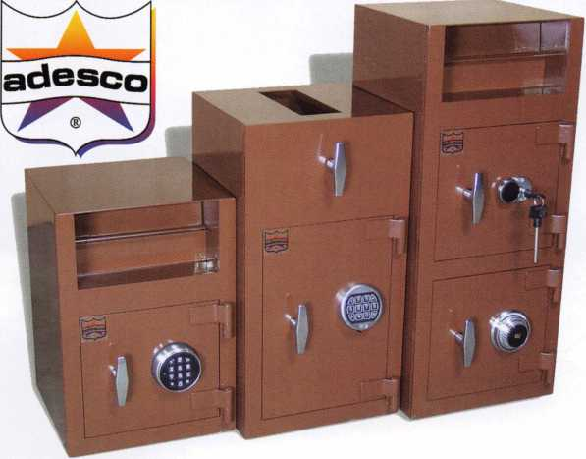

New from Adesco.  
The Latest Technology  
at Affordable Prices!

**Special Introductory Pricing and  
Promotions Available Now.**

Introducing the all new Business Deposit Safes from  
Adesco. Safes feature precision plasma cut doors and  
solid 1/2" monoframe faceplates. Door jams are reinforced  
and tied to safe sides. Postal drops offer our famous  
recessed baffle technology. *LaGard’s all new Group 2M

combination locks and spy-proof dials included  
at no additional cost. All these features  
and more at an economy price!

Call your Adesco distributor today.

*When available

(800) 694-9340 • [www.adesco.com](http://www.adesco.com) • [safes@adesco.com](mailto:safes@adesco.com)

Keynotes • June 2004

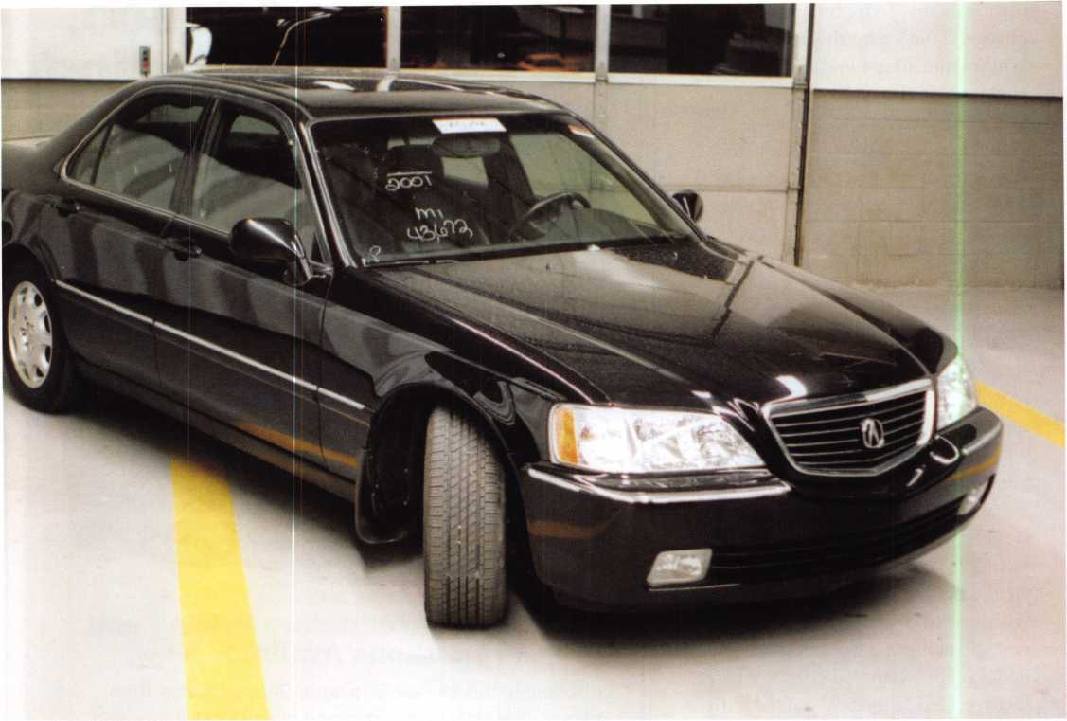

2001 ACURA 3.5RL:

G A KEY AND CLONING IT

TRANSPONDER Equipped (CODE SERIES 5001-8442)



Keynotes • June 2004



There are still too many locksmiths out in the field who are letting the automotive dollars slip away because tech­nology and education seem to be too demanding. They aren’t, and this series will aim to help show how simple (and lucrative) next-generation automotive locksmithing can be.

Our subject is a 2001 Acura 3.5RL - chosen for the supposed difficulty in dealing with the Honda system, as refer­enced by many experts. Let’s take a look:

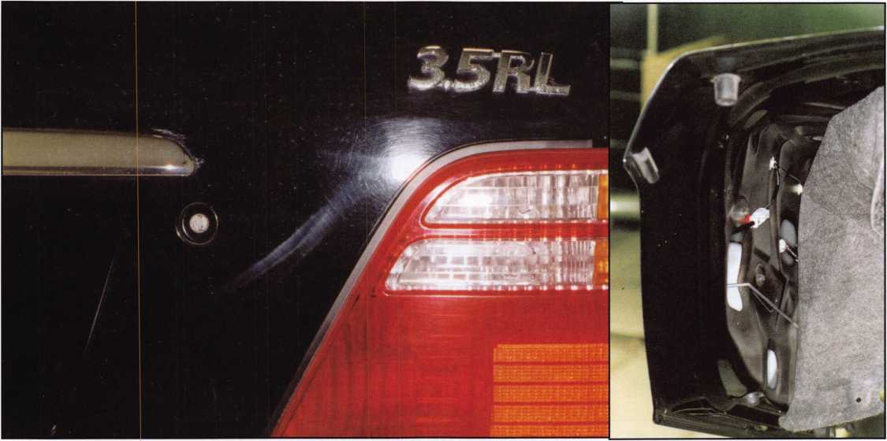

1. We start by gently prying out the plastic tabs, and move the cover enough to expose the trunk lock, and take a close up look at the trunk lock.

2. Next, we disconnect the lock rod.

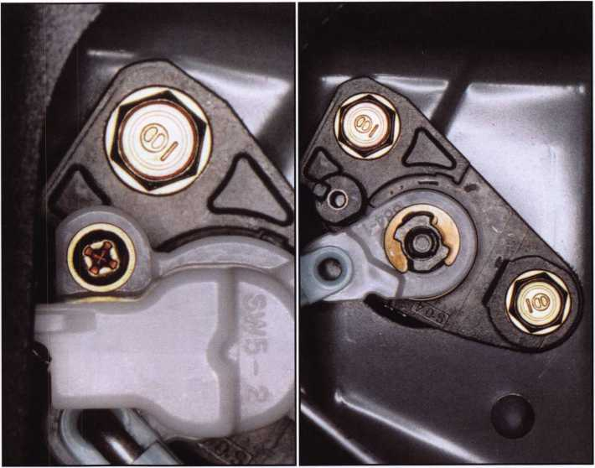

3. Remove the Philips screw

Then we gently remove the electric release assembly by using a small screwdriver to slightly bend the tabs out of the way.



Keynotes • June 2004

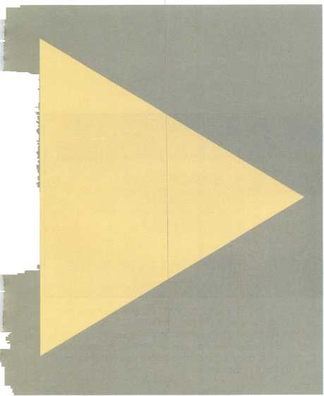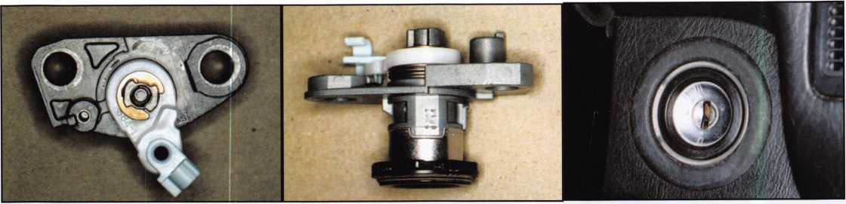

5. This is a close up of what has been removed and 7. what we need to do next: remove both 10 mm bolts along with the trunk lock, from the inside.

The top of the lock and shows two rows of num­bers. The bottom row of four numbers is the key code 6511. Now you would cut a mechanical key by code to check it in the ignition cylinder and other locks (use key blank #110-103 when cutting the mechanical key). Know your code series; it will help you to more easily identify key codes. Make sure that a 6 could not be an 8. It appears that looking through the drain hole at the bottom of the cylinder; it has 6 wafers, positions 3-8. The tail is free floating on the back of the trunk lock.

8. The ignition cylinder on the dash. Here we have a lighted ring and a hidden antenna ring for the key transponder system. Ignition removal requires dis­assembly of the front and lower dash. Upon removal of the light and antenna rings, just release the steering column; the ignition cylinder is held in place by a roll pin.

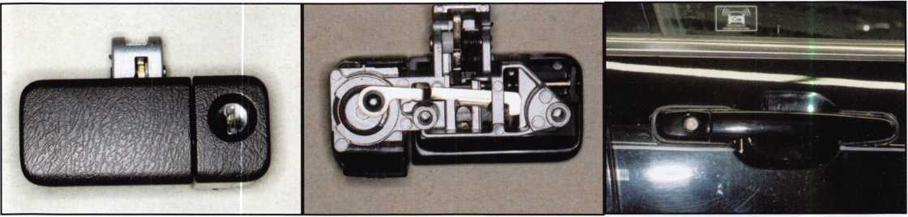

9. Here is the glove box lock, removed (no code

stamped on). To remove the glove ox lock assem­bly, you need to remove two Philips screws from the inside of the glove box, and the assembly comes out from the front. Also on the glove box is an ON/OFF switch for the trunk release; if the switch is turned off, you cannot open the trunk. From the trunk release located on the driver’s door panel, flip the switch to ON.

10. The back of the glove box lock. If you need to dis- 11. assemble, have a replacement retainer that goes on the post at the end of the cam lock; there are usually four wafers in the glove box lock.

The passengers door lock with warning label on the glass.

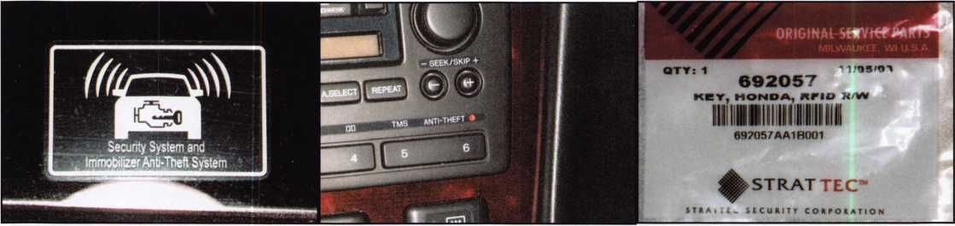

12. The anti-theft sticker.

13. The red theft light in the radio--another anti-theft 14. feature.

The key package, STRATTEC #692057; you can also use an ILCO key (#HD106PT and HD106PT5). The 5 indicated is a key that needs to be cloned. You can use an original; all cloneable keys need to be cloned before you can program them to the vehicle.



Keynotes • June 2004

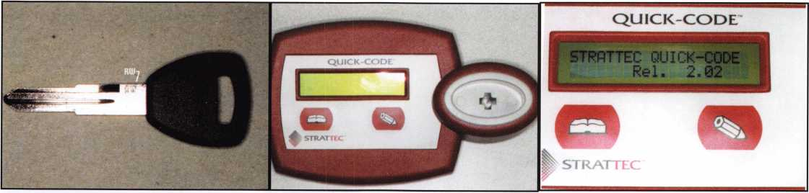

15. Key #692057; the RW stamped on the key means 16. The Quick Code. 17. Plugged into 110 volts,

that this is a read/write key that needs to be cloned before it can be used. There are two ways to clone: with an RW2, or a quick code. I own a quick code, so let’s use it to demonstrate.

QUICK-CODE

QUICK-CODE

5ERT THE KEV

AND PRESS READ

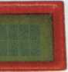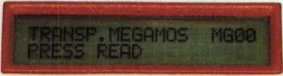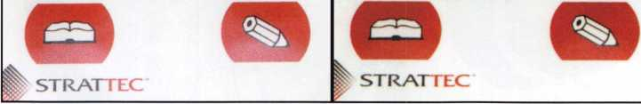

quick-code

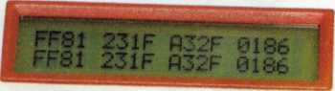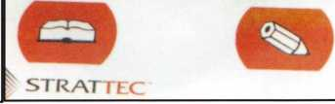

18. Step one: Insert key and press READ. 19. A transponder key is detected; press READ again 20. The transponder valve; press READ again.

- we are cloning from an original key.

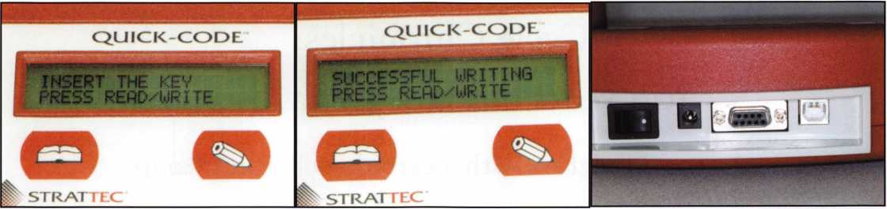

21. Next step: Press WRITE. 22. We are successful! 23. The back of the Quick Code, where you can con­

nect it to a computer and save customer data for future use.

Keynotes • June 2004

**2**

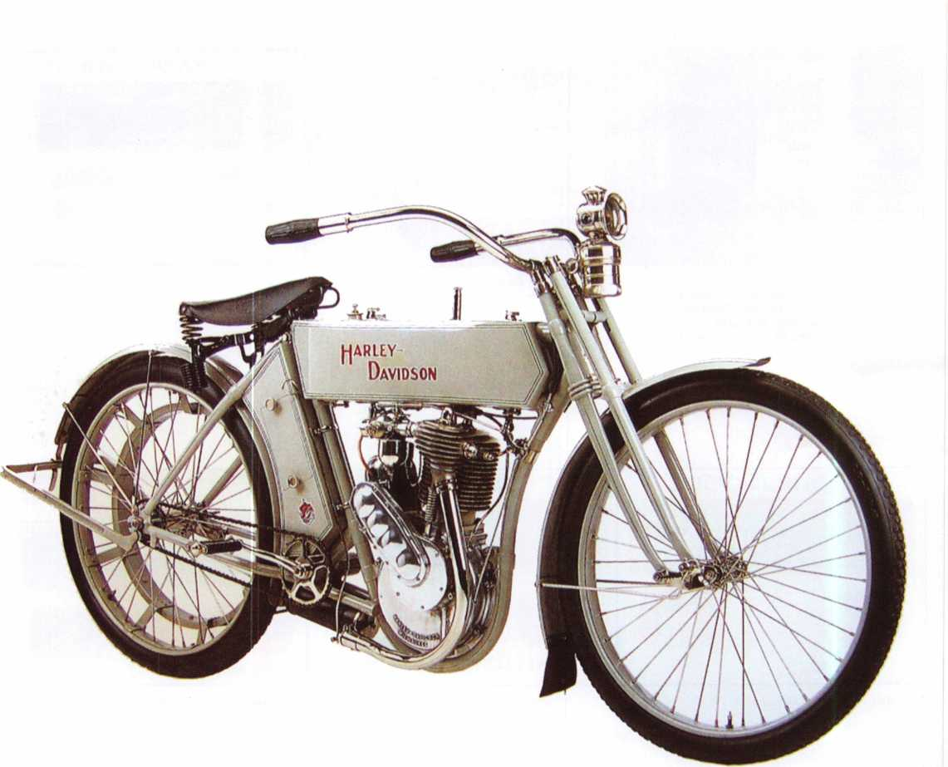

Cycle Chronicles:  
ioo years of Harley-Davidson

A 1909 Model 5A with a carbide pellet headlamp



Keynotes • June 2004

In 2003, Harley-Davidson celebrated its 100th anniver­sary Officially its legacy begins slowly and humbly at a small Milwaukee Wisconsin shop in 1903 where three young men, Walter Davidson, Arthur Davidson and William S. Harley produced their first motorcycle. Is that what really happened? How did it all really begin?

In 1901, 21-year-old William S. Harley and 20-year-old Arthur Davidson met each other while working for the same company Both avid anglers and somewhat mechanically inclined, they became friends and spent their spare time building an outboard motor, which they hoped would take them to their favorite fishing spots. But a nagging distraction, the newfangled “motorcycle,” began shifting their attention. William had previously worked in a bicycle shop, and Arthur had been trained in school as a pattern maker. Neither had any money to buy a motorcycle, so together with Emil Kroger (a draftsman friend who had worked in Europe on prototypes of the de Dion internal combus­tion engine), Harley and Davidson looked away from their outboard motor project and set their sights on building a motorcycle. Little did they know their proj­ect would consume all their spare time for the next two years, but here were three young men preparing to have a lot of fun, and at this point in their lives, creating the mighty Harley-Davidson Empire was the furthest thing from their minds.

Their first bike was little more than a power-assisted bicycle. (Note one of the pedals in photo #1.) The ped­als were to get the bike started and going, and when

necessary, back home when, for whatever reason, the engine stopped running. But the engine they had cho­sen was not very powerful, working well on flat terrain but not well on inclines; so on their first bike, the ped­als were also needed to climb hills. They needed a big­ger engine! So while Arthur Davidson’s brother, Walter, was in town for their older brother William’s wedding, Arthur convinced Walter, who was working as a machinist for the railroad in Kansas City, to transfer to Milwaukee and spend his spare time along with them on a “next generation” engine. Meanwhile, locals began asking when they could have their own bike built, so as the three young men worked out the engine problem, something else happened that would change the course of motorcycle history. They decided to build the next bike with the intention of selling it!

In 1904, they produced not one but two bikes! Both were equipped with larger engines and other improve­ments over the first bike. Even the Davidson brothers’ Aunt Janet Davidson pitched in. She created the Harley-Davidson logo, painted it onto the gas tanks and pinstriped the bikes before sale. In 1905, they produced eight bikes, and then another 50 in 1906. In 1907, the third Davidson brother, William A. Davidson, joined the company and the four men formed a corporation: the Harley-Davidson Motor Company. That year, they produced 150 bikes, and in 1908, they produced over 400. During World War II, over 88,000 Harley- Davidsons were sold to the U.S. Military alone, and today as well, thousands are made and sold every year.

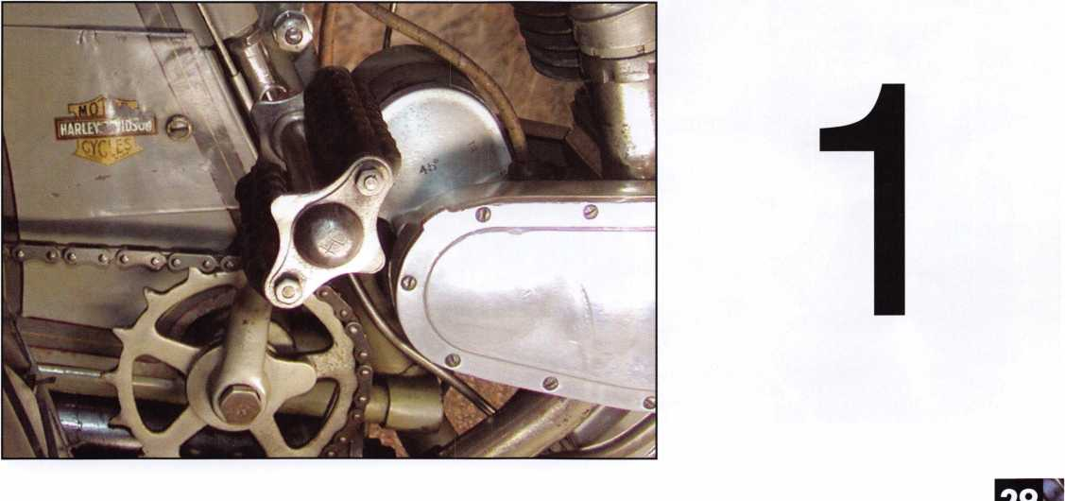

Keynotes • June 2004

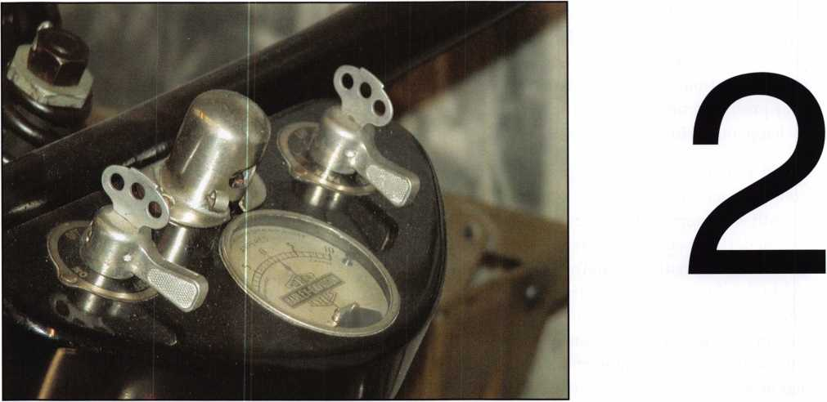

1903 - Late 1920s

Harley-Davidson’s first model, Silent Grey Fellow, was not fitted with locks -- just a simple ground switch to shut down the engine. It wasn’t until the late 1920s that locks began appearing on motorcycles. The early locks were primitive by today’s standards, but state-of-the-art for their time. Remember that since the end of the 19th century, most automotive locks utilized warded or lever

locks and flat keys; these designs were invented, per­fected and patented by Linus Yale in 1869. (Note the two warded switch locks set into the console of a 1929 Model C, pictured in photo #2.) The one on the left side of the ammeter is the ignition switch. The one on the right is the light switch. The keys are inserted at the top. Note the key bow protruding from the top of each switch. After the keys are inserted, the levers are rotat­ed manually to operate the switches.

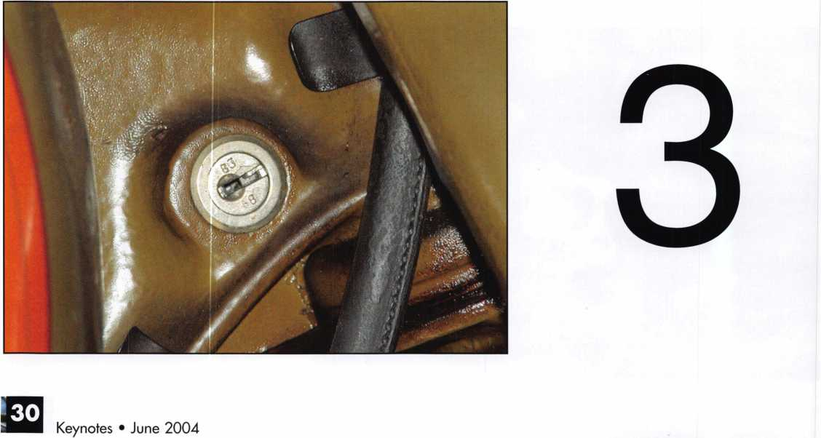

1930s - 1960s

Code Series: EC1-11LL226-450 B250-499

Key blank: CGi CG16 Bi

In the early 1930s, what we now call the standard disc lock became popular for vehicle use. Harley-Davidson contracted the services of various U.S. lock manufactur­ers during this period. In photo #3, a Briggs Sc Stratton standard disc lock, complete with key code B-368 stamped into the face of the plug, can be seen. From the 1930s and throughout the 1960s, other U.S. lock manufacturers, such as the Chicago Lock Company, were contracted by Harley-Davidson to supply locks. Harley-Davidson’s relationship with U.S. lock manufac­turers remained strong until 1969, when Harley- Davidson was bought by American Machine Sc Foundry, also known as AMF.

The AMF Period (1969-1981)

1970 - Early 1980s Code Series: 43-118 Key blank: X93-X127

During the AMF period, some locks were procured from offshore manufacturers. Photo #4 displays an example of an AMF period ignition switch. This switch lock, which we found on a 1972 X-90, is single bitted,

and depending on the lock broaching and key code, the key could be either single or double bitted. The lock is mounted to the side of the bike about knee high, and secured with a bezel nut. Note the key code #93 stamped into the side of the casing just beneath the bezel threads. Many stock key blanks were used, but only two depths or “steps” were used: a cut and a no cut. Aftermarket switches were not coded, nor did they utilize stock key blanks. This lock utilizes a dust shut­ter, which is spread apart by the tip of the key, as the key is inserted. Original keys were beveled at the tip to facilitate opening the dust shutter, but many aftermar­ket key blank manufacturers skipped the beveling step of the manufacturing process. That means these blank tips need beveling before they can be easily put into the lock.

Though AMF dramatically boosted the number of bikes produced per year and was eventually credited for keep­ing Harley-Davidson alive and in the public’s eye, 1969 through 1981 quite possibly was the most difficult peri­od Harley-Davidson ever endured. For, as quality of manufacturing declined, the simultaneous encroach­ment of competing Japanese and German bike manufac­turers further cut into Harley-Davidson’s market share. Ultimately, it would take years after the company was bought back from AMF to recover from these malign­ing circumstances. Next month, when Cycle Chronicles returns, we’ll look at life after AMF and onward into the 21st Century.

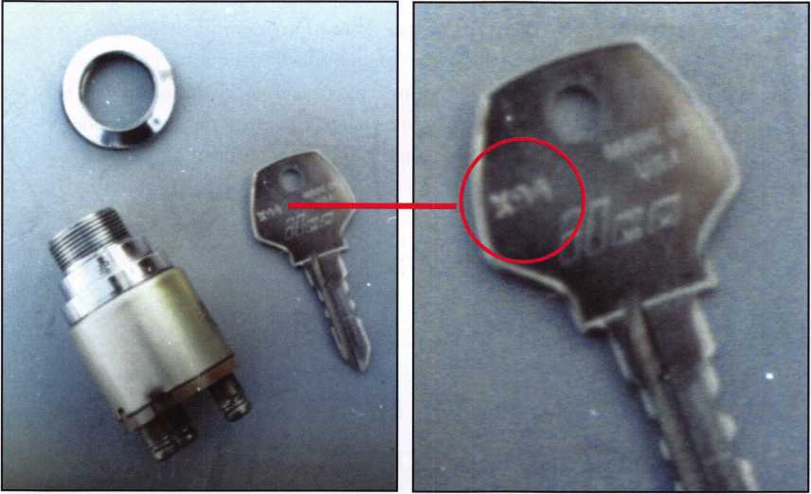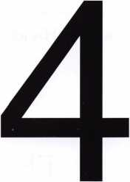

Keynotes • June 2004

If you want to pass the Safe Technicians Proficiency  
Program Certified Professional Safetech, or STPRP  
CPS exam you need to read Mike Oehlert’s “Safe  
Technician Reference Manual.” This is a commonly

accepted industry reception  
to Mike’s book. I have been  
hearing for years about this  
“must have” book. I’ve  
looked at it a couple times,  
and at first glance, thought  
it contained some good  
information; but I’ve already  
passed my CPS exam -- how  
much more could it teach  
me? Plenty!

I finally broke down and  
purchased a copy. The book  
contains a lot of excellent  
basic information. Basic  
information can be good; in  
some cases, it will reinforce  
what you already know.

Other times, it may correct

some misinformation you learned years ago. I know  
this book did both for me. Mike does an excellent job  
of covering the basics of safe work. From cast-iron  
safes to safe deposit and vault locks, this book gives an  
introduction to all facets of safe work.

Mike is the current editor of SAVTA’s monthly maga­zine, Safe & Vault Technology, as well as SAVTA’s hot­line advisor. In other words, he’s the chief cook and bottle washer. His job duties also include SAVTA edu­

cation manager and safe mover for the convention, as  
well as few more headaches he just sort of quietly han-  
dles. He has held this position for io years. Before  
becoming the technical advisor for SAVTA, Mike

worked in the field as a safe tech-  
nician for 20 years. Most of that  
time was spent as a field techni-  
cian for Tann safe out of Dallas.  
This is where Mike received most  
of his experience in high security.  
Speaking to Mike, I found out  
that although ALOA advertises  
this book as the study course for  
the STPRP, that was not his orig-  
inal intention. He found a general  
lack of understanding by many of  
the SAVTA members calling into  
the hotline. Mike also noticed a  
lack of published fundamental  
information for the technician.  
There was (and still is) a large  
amount of information on how to  
drill safes open, and some infor-

mation on diagnostics, but little has been written on  
the basics. Unfortunately, many of us took a class or  
two and only want to swing the handle in the least  
amount of time. We really don’t want to learn the  
basics first! We’ll just pick up that stuff as we go along.  
Most of you can relate to the new hire who wants to  
be taught how to pick a lock without having to learn  
how the various types of lock mechanisms operate or  
how to rekey a cylinder. Opening safes before under-  
standing the basics is the same thing.

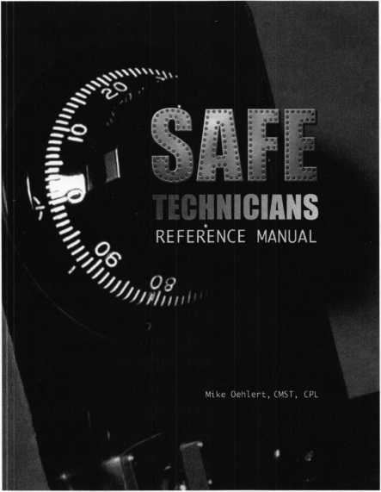

Book Review:

The Safe Technicians Reference Manual

By Mike Oehlert, CPL, CMST

Reviewed by Greg Perry, CML, CPS

**32**

**HI** Keynotes • June 2004

Where does Mike’s book start? At the beginning! Of course, starting with how to create your own library of information. Creating your own library is important for two reasons, first if you are like most of us in this industry we learn best by having our hands on the product. Disassembly, measuring and reassembly help to reinforce our memory. Reading is important and works as a guide, but the best way to learn is with hands on training. Second as time goes on your library will guide you with opening and help to jog your mem­ory. Every time I come across a new lock or safe I take the time to stop and study it. I look at the construc­tion for its strengths and weaknesses. I also look at the lock, how is it mounted, which model lock was used and why. I always take the time as Mike suggests, taking pictures of the safe and recording all the details. Yes this takes time away from other jobs and on a busy day it may not seem productive or impor­tant, but I consider it just another part of the job like writing the invoice. Next Mike covers how doors and locks are handed, then how safes are constructed.

After construction Mike discusses how to effect repairs. At first you might ask why discuss repairs before drilling? The answer is simple if you don’t understand and know how to repair any damage done during the opening, then you have no business putting a hole in the safe.

Now that we have an understanding of safe construc­tion it’s time to look at how the locks are constructed. Mike explains how all the parts are interrelated and gives a very good overview of the majority of locks a technician will find in the field. Next up, Mike finally gets to the opening part. Mike covers drill points and opening techniques including transferring, angle drilling and the tools necessary to open safes. This is one area I believe Mike puts the cart in front of the horse; I think diagnostics, troubleshooting and manip­ulation should come before the drilling part.

Mike goes on to cover contact points, combination changing troubleshooting, and manipulation diagnos­tics in the next chapters. Here is an area I think might be expanded. I know that in hindsight I wish I had been taught manipulation first. Instead, I learned how to drill and was told manipulation is only for the expert safe cracker. Learning and understanding manipulation first should be required of safecrackers before learning how to drill.

GSA (General Services Administration) Containers DOD (Department Of Defense) and Federal Standards are covered in depth. The majority of infor­mation is still current, although there are two addi­tional locks (the KabaMas X-08 and X-09) have been introduced since this book was first published. GSA containers require a different approach and are typi­cally only seen in military areas. Mike does a nice job of covering the differences from commercial work and explains where to find more information.

Mike also does a nice job of covering most of the vari­ous electronic, mechanical locks produced. He gives some information on timelocks and safe deposit locks. I believe this is the only one-stop reference source that lists spindle sizes and splining, in addition to con­tact points. These can be handy if you need to replace parts or for determining which lock might be inside, with only a few clues from the outside.

Mike has done a great job of presenting information helpful to all technicians. The beginner should read and study this book. The more advanced technician will appreciate the one stop source for lock ID’s and will probably even pick up a few tips from a true expert in safe and vaults.

ALOA members can purchase the Safe Technicians Reference Manual at a 15%  
discount in the ALOA Store either online at [www.aloa.org/store/merchant.mv](http://www.aloa.org/store/merchant.mv) or by

phone 800-532-2562.

Keynotes • June 2004

The Maryland Locksmith Association (MLA) is proud  
to host the 2004 ALOA Convention and Trade Show  
in their home state. Many MLA members live or work  
just a short distance from the Baltimore Convention  
Center—the site of this year’s show. MLA will have a  
booth on the ALOA Convention floor. They hope to  
meet and welcome all attending the 2004 ALOA  
Convention.

Celebrating 50 years as an association, MLA was cre-  
ated for locksmiths to learn more about the trade and

to provide valuable training  
for apprentices. They contin-  
ue to uphold the highest stan-  
dards in the industry, as secu-  
rity professionals. As the  
needs of their membership  
change, MLA continues to  
meet the challenge. They pro-  
vide a unified, professional  
locksmith voice in Maryland.

Security professionals in the  
state of Maryland are encour-  
aged to attend MLA meetings

and become active members. The MLA offers training  
at a fraction of the cost elsewhere and represents the  
greatest resource of experienced locksmiths in the  
state. Participation keeps members up-to-date on  
what is happening locally in the industry. MLA pro-  
vides a means by which a voice can be heard—not just  
as one—but as an association of professionals with  
specific needs, desires and concerns about the security  
industry.

The membership, now 127 strong, includes locksmiths from all over Maryland. With Maryland’s diverse geog­raphy and industry, there is a great deal of information to share. Members come from all types of locksmith businesses—from the mobile operation to full service

store settings. There is a good mix of security profes-  
sionals performing residential, institutional and com-  
mercial work. Some members specialize, or are solely  
involved in, one particular area of the trade. Some  
members work time is spent primarily performing  
auto work, while others do a great deal of access con-  
trol, CCTV or safe work. It is this variety and mix of  
expertise that makes the association such a valuable  
asset to its membership.

Lance Edwards, past President of MLA, has been

involved with the industry  
for 15 years. He took a  
locksmithing course prima-  
rily as a hobby. Lance  
spent 10 years as a part-  
timer, “honing lock-  
smithing skills” while  
working in another indus-  
try. He gained much valu-  
able knowledge from his  
involvement with MLA.  
His “hobby” has now  
grown into a full-time  
career. Five years ago, he

decided to go full-time in the industry “I have been  
happy ever since,” he said. He now has a full time,  
family-run business with three trucks on the road.

David (Dave) Fullarton, CPL, CPS, is the newly-elect-  
ed MLA President. He sold his full-service business in  
North Carolina in 1997, where he had two shops and  
four trucks, to go back home to Maryland. He now  
does safe and vault work exclusively under the name  
Safeworks.

As President, Dave wants to focus his attention on  
“moving MLA into the 21st Century” by doubling the  
membership and adding more industry resources.  
Placing major focus on helping the beginners in the

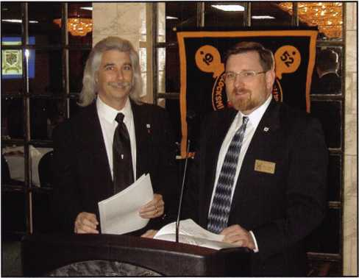

Meet the MLA

By Claire Cohen, CML

Keynotes • June 2004

industry is of prime importance to MLA. “That’s  
what we’re here for,” he explained.

Dave frequently is asked, “What’s in it for me? Why  
should I join MLA?” His response is full of enthusi-  
asm. Networking with other locksmiths can be a huge  
benefit. Experienced members can help provide  
knowledge of techniques as well as where to get parts,  
or even which parts to get. “Educating ourselves and  
passing our accumulated knowledge to others is the  
future of our profession,” he said.

Many business meetings are held in a restaurant/ban-  
quet facility. Guest speakers and members are invited  
to conduct after-dinner classes and programs. These  
include topics such as new products, servicing tech-  
niques and legislation. Licensing and legislation are  
the two most important issues for MLA membership.

Classes are a major part of the association focus. A  
pizza dinner followed by an interesting class on elec-  
tricity held at one of the local high schools proved to  
be a great meeting. Another popular class was the X-  
09 electromechanical safe lock class.

Bob DeWeese, CML, a past president of MLA,  
taught a two-day auto class. The first day of class was  
held in a classroom. Participants spent the second day  
at a local junkyard to practice techniques learned the  
previous day—making auto keys for any car in the lot.  
“Almost everybody still signs up for auto classes,” he  
said. But increasingly, MLA members are getting away  
from automotive work.

For example, upcoming classes include Basic Safe  
Opening and Access Control, both taught by MLA  
members. It doesn’t hurt to have some industry  
experts on the MLA membership roles!

This past year, one of MLA’s most successful and  
enjoyable functions was a cookout/van show/swap  
meet, held at the Baltimore Raven’s Football Stadium  
in downtown Baltimore. The parking lot was the  
scene of members sharing food and friendship. Many  
vans were on exhibition. There were even awards for

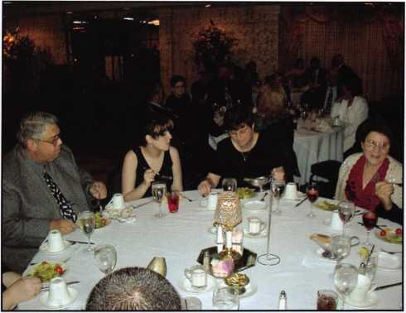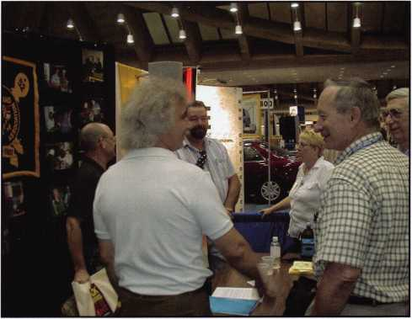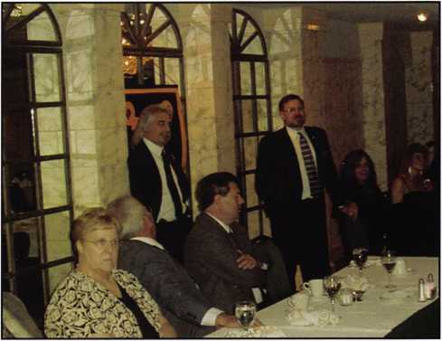

Keynotes • June 2004

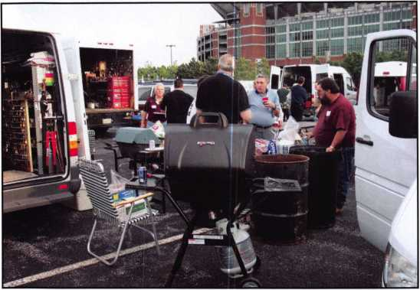

this is to select a member(s) who is new to the industry, or a needy member, who would not be able to attend a class otherwise.

A “Hardship Fund” has been created to provide emer­gency assistance for fellow members in need to due health, injury or other issues. Anonymously presented, the MLA Board votes to award money to a fellow mem­ber “who has fallen on hard times.” The amount “can’t solve anybody’s problems entirely,” but is a token of the association’s concern and dedication to support its members in time of need.

the “Best Equipped Van” and “Best Appearance Van.” Everyone attending seemed to enjoy looking at the vans, the food and the camaraderie. The swap meet was a good place to find buyers for merchandise others no longer needed. Everyone loves a bargain! Next year’s function for a similar event will have an extra-added attraction—the Baltimore Ravens Security Team will host a tour of the Raven’s stadium.

MLA is associated with the Chesapeake Chapter of ALOA and holds Chapter meetings after most MLA meetings. MLA is supportive of ALOA and the PRP program. They encourage members to form study groups and gain PRP certification. They recognize the value of the tests, and encourage education and profes­sional efficiency.

Last year, MLA sponsored a mini convention/educa­tional weekend in Jessup, MD. This location (about half way between Baltimore and Washington, D.C.) was the scene for the convention, classes and meetings. Among the classes taught were impressing, auto, and access control.

A sometimes overlooked benefit of membership in MLA is their education/scholarship fund. Each year, scholarship funds are set aside to pay for tuition to ALOA, SAVTA, or other industry related classes. Members can apply for this scholarship. The purpose of

Every year, the association works with various charities. Last year, MLA joined with the U.S. Marine Corps in their Toys for Tots campaign. They collected toys for needy children and distributed them during the holiday season.

MLA works closely and supports other locksmith asso­ciations. As a group, they attend functions sponsored by other associations, including The Greater Philadelphia Locksmith Association (GPLA), and the Locksmith Association of Washington, D. C.

MLA maintains a web site ([www.mdlock.org](http://www.mdlock.org)), which was created to share information with fellow members. This site has a message board for discussion groups, job postings, industry web links as well as a posting of upcoming events.

A quarterly newsletter is published by MLA member, Sam Haney, who has a background in public relations and publishing.

MLA encourages locksmiths in the “Old Line State” to contact the association regarding upcoming meetings, classes and other events. Members of the board can be contact via their web site. Members look forward to welcoming all attending this year’s ALOA Convention in their home state, Maryland!

Keynotes • June 2004

Bold Initiatives Point to Bright Future

for Revered Lock-maker Sargent & Greenleaf

When most security insiders think of Sargent and Greenleaf, they envision one of the world’s most respected players in lock and safe technology. Operating continuously for nearly a century-and- a-half, Sargent and Greenleaf is, after all, one of the grand old names in the security industry. But now it is the future, rather than the prosperous past, that occupies the minds of those close to the company.

“I believe the word most associated with the Sargent and Greenleaf brand now is ‘innovation,’” says president and chief operating officer Bill Dempsey. “Personnel, products, distribu­tion...every decision we make, every initiative we launch is being guided by our desire to listen to our customers and develop the best products to meet their needs and grow our company.”

Dempsey himself is part of a newly reorganized management team charged with ushering in Sargent and Greenleaf’s continued future success. While he acknowledges the team will benefit the company greatly, he is quick to put the emphasis back on the impressive slate of new products being introduced by S&G.

“Our electronic and mechanical locks are setting today’s stan­dard, and that’s great,” says Dempsey. “Now it’s time to show our customers and business partners that we’re poised to bring a similarly high level of innovation to other safety and security applications.”

New Products

The North American introduction of Sargent and Greenleaf’s groundbreaking ASKO System brings that point home. Already being successfully implemented throughout Europe, the ASK System is revolutionizing the management of safe deposit boxes, as well as high-security lockers and cabinets, through automa­tion, according to Dempsey. Featuring a simple touch screen interface, PIN and swipe card operation and low maintenance design, the system eliminates the use of safe deposit keys and the headaches that accompany them.

The launch of Sargent and Greenleaf’s second-generation A- Series™ ATM Access Management System is another highlight. Using a reliable MicrosoftO SQL2000 database design, the sys­tem enables centralized access control of an ATM network and helps maximize ATM uptime. Another key feature of the new A- Series system is accurate audit trails due to the elimination of time drift problems. The system will also save users money and logistical headaches thanks to the elimination of bank user keys.

One of Sargent and Greenleaf’s most ambitious products is the IP SeriesO remote security management system. Using an advanced LANA/VAN network platform, the IP Series system pro­vides remote management of electronic locks throughout a user’s entire enterprise. The unique system can also be connected to security cameras, sensors and other peripherals, enabling fully integrated security management and real-time monitoring of all lock activity. The new system debuted during the Sicur Show in Spain in February and will be introduced in other markets later in the year.

Sargent and Greenleaf expanded their successful electronic lock line-up in February by adding the Rotarybolt™ Z02. This new electronic lock is a first in the Rotarybolt family and is based on a patented S&G solenoid bolt design. The Z02 offers users superi­or programming flexibility, time delay and other commercial lock features.

“Through our new product launches this year, we’re moving beyond on-location security and using our expertise in electronic security solutions to develop products that focus on full-enterprise security integration, regardless of application,” Dempsey notes. “Obviously, the key benefits to the customer are simplified opera­tion, significant cost savings and much greater accountability, all backed by Sargent & Greenleaf’s proven record for quality.”

Executive Team Supports New Strategies

Driving the bold initiatives at Sargent and Greenleaf this year is an experienced and capable team. Following the promotion of long-time president Jerry Morgan to chairman and CEO, the com­pany promoted Bill Dempsey to serve as president and chief operating officer. Dempsey joined the company in 2003 as execu­tive vice president. He previously served in senior management positions with Ashland, Inc. Dempsey and his operating man­agement team will be responsible for implementing and managing the company’s new strategic initiatives.

Sargent and Greenleaf also named Bryan Callihan its corporate controller. An 18-year Sargent and Greenleaf veteran, Callihan most recently served as the company’s manager of accounting.

Signaling a renewed emphasis on marketing, Sargent and Greenleaf hired Phil Pitt to serve as marketing manager. With more than 20 years of experience in marketing and product man­agement, Pitt previously held senior marketing positions with Source Technologies, Inc., based in Charlotte, North Carolina and with Lexmark International in Lexington, Kentucky.

Sargent and Greenleaf also announced promotions within its sales and product development team. The company named 17- year Sargent and Greenleaf employee Ned Urschel vice presi­dent of sales. Urschel will oversee the company’s sales activities in the United States, Europe, and Asia. He was previously vice president of product and market development. Taking Urschel’s place will be Michael Clark, who moves up to the role of manager of product development.

Sargent and Greenleaf, headquartered in Nicholasville, Kentucky is the world's leading manufacturer of medium and high security locks and locking systems. Since 1857, Sargent and Greenleaf has provided security solutions to financial institutions, commer­cial businesses, governments, and consumers around the world. Delivered through an international network of distribution part­ners, Sargent and Greenleaf products continue to set the stan­dard for quality, value and technical innovation. For more informa­tion, visit the company online at [www.sargentandgreenleaf.com](http://www.sargentandgreenleaf.com), or call (859) 885-9411.

|  |  |  |  |  |
| --- | --- | --- | --- | --- |
|  | g|| e c | CO  • | 1 ◦ 1 | a)  >  • |
| ■BJEg | W' u p | d a t | e |  |

**Greetings from Dallas!**

This month marks my first year anniversary as ALOA's Government Relations Manager. The last 12 months have seen enormous changes in the legislative issues affecting locksmiths. It's simply been the most exciting and rewarding time of my entire professional career.

Licensing laws are being implemented across the country, and ALOA has been at the forefront of the process. ALOA joined a coalition and lobbied strongly for association health plan legislation that recently passed the U.S. House of Representatives. Even our quest for more automotive infor­mation has made waves, as ALOA recently helped set up and attended a very promising meeting in Detroit.

Legislation is a fickle creature. Quite often, the best laid plans of mice and men go awry. Then other times, seemingly insurmountable tasks are conquered overnight. We are constantly beholden to the whims of politicians. Still, I wouldn't have it any other way. ALOA has become a force nationwide. Legislators in state houses all over the United States are beginning to take notice. It's a great time to be a part of this association.

I love my job, I am honored to represent this great industry and I plan on celebrating many more anniversaries from my desk here at ALOA headquarters.

I look forward to seeing you all at our 2004 Convention!

Regards

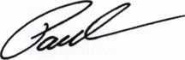

Paul Kanitra

Government Relations Manager

Keynotes • June 2004

Motor Vehicle Right to Repair Act:

I recently helped organize a meeting in Southfield, Michigan. Board member, Mark Blum also attended. The meeting's purpose was to specifically discuss our issues with the automobile manufacturers. Eight different manu­facturers were represented either in person or via teleconference. Also in attendance were other highly qualified locksmiths, representing various areas of our industry. Things pro­gressed nicely and an agreement was laid out to get specific responses within two months.

A locksmith committee of sorts has been formed and is currently working on a graph to present to the manufacturers by June 1 st. The manufac­turers will have responses on each specific issue within a month.

This development will eventually get more infor­mation available to locksmiths looking to work on cars that they had previously been unable to work on. After the information that still isn't available is relayed to the manufacturers, talks will begin on the release of this informa­tion as well.

Our legislative angle is also still being pursued. We are curently up to 95 co-sponsors in the US House of Representatives and recently secured a sponsor for the Senate companion legislation.

Association Health Plan Legislation:

Just a few short days ago, the US House of Representatives approved the Association Health Plan bill (H.R. 4281) on a vote of 252- 162, with nearly all Republicans and 37 Democrats supporting the bill. This vote is very similar to the vote on the identical H.R. 660 in June, 2003 (262-162), with the difference apparently being the number of members of Congress not voting due to absence. This is another strong victory for the AHP legislation!

A rule approved by the House combines H.R. 4281 with two other health care related bills and sends all three as a package to the Senate. Thus, if the Senate acts on any of the bills on an individual basis, it will be easier for the House to include all three in any future conference committee with the Senate. The other bills are a medical liability reform bill (H.R. 4280) and a bill to allow taxpayers to roll over up to $500 in unused benefits in their flexible spending accounts, or transfer unused funds into HSAs (H.R. 4279). These bills were approved by the House on May 12 on votes of 229-197 and 273-152, respectively.

Keynotes • June 2004

Classifieds



EMPLOYMENT

FOR HIRE

Product Manager

Kaba llco Corp., the world leader in the manufacture of key blanks, key cutting machines, and replacement cylinders, is seek­ing a Product Manager, responsible for the strategic direction and marketing of automotive transponder keys and equipment. The ideal candidate will possess a strong understanding of auto­motive diagnostics and automotive key generation and program­ming.

Responsibilities:

Direct and perform all aspects of product development, product changes and product promotions.

Manage and communicate sales and technical information for internal and external business customers.

Develop and maintain a pricing program that balances competi­tive challenges and at the same time meets revenue growth and profit objectives.

Prepare the marketing plans for assigned product lines and rec­ommend changes to meet market and competitive conditions.

Conduct field test of product software and hardware to insure market needs are met and design training programs for distribu­tion and end users to understand the applications of each.

Leads internal research efforts to identify automotive and security trends pertaining to the product line.

Managing all elements of the product line support requirements including merchandising, advertising, literature, website informa­tion, etc.

Skills/Education:

* Four year degree in Business Administration, Marketing or related technical field.
* Minimum of four years experience as Product/Brand Manager/Engineer for a technical product related to automo­tive diagnostics or automotive security.
* Strong written and oral communication skills.
* Proven ability to prepare and implement business plans and strategic assessments.
* Must have proficient Microsoft Office Suite experience in Excel, Word, PowerPoint

Interested candidates may send their resume with salary history in confidence to:

Human Resource Department, Kaba llco Corp., P.O. Box 2627, Rocky Mount, NC 27802, fax: 252-446-4702, or e-mail to [resume@irm.kaba.com](mailto:resume@irm.kaba.com) An EOE M/F/H/V.

EXPERIENCED LOCKSMITH WANTED

Harris County is seeking an experienced Locksmith For informa­tion please see website

http:/ / co.harris.tx.us/hrrm

Or call (713) 755-5906 all applications must be applied in per­son •1310 Prairie, 2nd floor, Houston, Texas 77002

BRANCH MANAGEMENT MANAGER

Safemasters, an established company, has an outstanding oppor­tunity in the Boston area for a results driven manager with a proven record. Preferred candidate will have, supervisory and admin skills, strong people skills, P&L exp.& sales ability. Responsibilities include directing & motivating a growing team including locksmiths and dispatch & inventory, and growing the market through sales, productivity & profits.

Prior experience in physical security, alarms, access control, or locksmith field helpful.

Our associates enjoy an equitable salary plan plus generous incentive and bonus plans for results oriented managers, and comprehensive benefit plans including 401 (k) and company matching plan. If you have a proven record and are looking for a company that both supports and encourages associates, forward your resume with salary history today.

Safemasters - Operations #93 Email: [hr2@safemasters.com](mailto:hr2@safemasters.com)

FAX: 800-233-2454 attn. Bryan Shaffer - #93 Voice Mail: 800-295-4702 xl54

LOCKSMITH FOR HIRE

Immediate opening with a full-service locksmith & security com­pany located in Aurora, CO. Seeking a Senior Service Technician proficient in all phases of locksmithing including safes and electronics. Company vehicle will be provided including all maintenance and fuel on vehicle. Benefits include a 401-K plan, Health Insurance, Vacation and Holiday Pay. Salary negotiable.

Contact: Sheila or Susan • Arapahoe County Security Center

15200 E. Iliff Ave • Aurora, CO 80014 • phone: 303-745- 5500

fax: 303-745-5567

LOCKSMITH FOR HIRE

Locksmith, South Orange County, CA. Excellent opportunity for experienced technician in access control, safes and standard locksmith work. Van and all tools provided. Excellent pay and benefits. Send resume or call Tony's Locksmith at 949/492- 5700. Fax to 949/492-0246.

STAR SAFE AND LOCK

Star Safe & Lock, a 57-year-old commercial locksmith company, is looking for a qualified locksmith and safe technician in South Los Angeles County to South Orange County, California area.

We will provide continuous training for the right individual but knowledge of locksmith basics is a must. Health and Dental insur­ance programs. Fax 801-469-1077. Email [info@starsafe.net](mailto:info@starsafe.net)

WANTED TO BUY/SELL

WANTED TO BUY

Safemasters Co. Inc. is seeking to acquire an additional lock­smith business in the greater Boston area. If you are an owner and would like to explore the possibility of selling your business, we would be interested in talking with you. Confidentiality assured. Contact Bryan Shaffer at [hr2@safemasters.com](mailto:hr2@safemasters.com), or voicemail 800.295.4702 (ext. 154).

FOR SALE

Mobile Locksmiths Business. 2002 Freightliner Sprinter. HPC Code Machine and code books, extra cutters. Lots of tools. Many years in area. Growing business. Buy and go to work, completely ready. Located in NE Maryland. Call 888/339- 5625. Priced to sell quickly. ALOA Member.

BLUE PUNCH

key machine #BP201, set up to cut Best "A" key blanks. Like new. $375. Call 972/727-2780.

BUSINESS FOR SALE

SMALL MOM-AND-POP

locksmith and glass business for sale in Golden Valley, AZ. Retirement is forced for health reasons. On busy US Highway 68. Golden Valley is between Kingman, AZ, and Laughlin, NV. In fast-growing Mohave County. Leased shop. Dodge Ram Van 2500. Both well-equipped and stocked. $65K plus equipment and inventory. Asking $48,900. All reasonable offers will be considered. New money only. Call 928/565-2294 or e-mail inquiries to [lmburks@ctaz.com](mailto:lmburks@ctaz.com).

BUSINESS FOR SALE

Growing East Tennessee locksmith business, established 1987. Supports three locksmiths, two fully equipped vans and building on corner lot fronting main highway through town. Shop cus­tomers, residential and commercial accounts ready for someone to take over. Call 423-586-3101. Monday-Friday. 8:00 a.m. to 5:00 p.m., EST.

Classified Advertising Policy

Classified advertising space is provided free of charge to ALOA members, and for a fee of $.60 per word, $15 minimum for non-members. Classified ads may be used to adver­tise used merchandise and overstocked items for sale, "wanted to buy" items, business opportunities, employment opportunities/positions wanted and the like. Members or non­members wishing to advertise services or new merchandise for sale may purchase a "Commercial Classified Ad," for a fee of $1.30 per word, with a minimum of $40. Each ad will run for two issues. For blind boxes there is a $5 charge to members and non-members. All ads must be submitted in writing to the ALOA office by the fifteenth of the month, fwo months prior to issue date. Send to Keynotes Classifieds, 3003 Live Oak St., Dallas TX 75204-6186. ALOA reserves the right to refuse any classified advertisement that it

deems inappropriate according to the stated purpose of the classified advertising section.

IN-ST0CK...M0RE SAFES

***FREE Freight Program***

***(30 States)***

AMSEC FireKing

Baidall **hayman**

MEIUNK yiCTOR

**TURPI t©**

**WHOLESALE SERVICE**

800**-**848-9790

25+ Function

IWlulti-Tool

**—** Lifetime Warranty —

FOR LOCKSMITHS ONLY

* 25 Functions  
► Services Schlage, Baldwin,

Corbin/Russwin, Lori,

Adams Rite, Master  
padlocks, Medeco, Arrow,

Jackson crossbars and

many more!

Call Toll Free..

888-634-LOCK

[www.lockmantools.com](http://www.lockmantools.com)



**THE HINGE DOCTOR**

by GKL Products

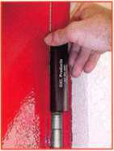

**HA1 For  
Standard**

**Commercial**

**4-1/2" x 4-1/2"**

**Butt Hinges**

**HA2**

*"The HULK*

**For Residential**

**COMING IN  
SEPTEMBER**

**HA3  
For Ball**

**Bearing &**

**Commercial Hinges**

**The Hinge Doctor is a great way to repair those sagging metal  
doors. Slip the tool over the hinge and open the door an inch**

**or two past the point where the tool binds against the**

**hinge, remove the tool and check the door,**

**which should now be working properly.**

**If you're a locksmith these tools  
will turn a profit the 1st time you  
use them!**Uses **- schools, hospitals,**

**commercial buildings, storefronts**

**with butt hinges, office doors, new**

**construction, door alignment, sagging  
doors, jail cells, anywhere there are  
commercial grade hinges.**

**HA4**

**For Prison**

**& Institutional**

**Hinges &**

**Spring Hinges**

US Patent **#6450003**

**[www.hingedoctor.com](http://www.hingedoctor.com)**

800-924-5397

Over

10,000

Satisfied

Customers

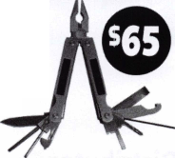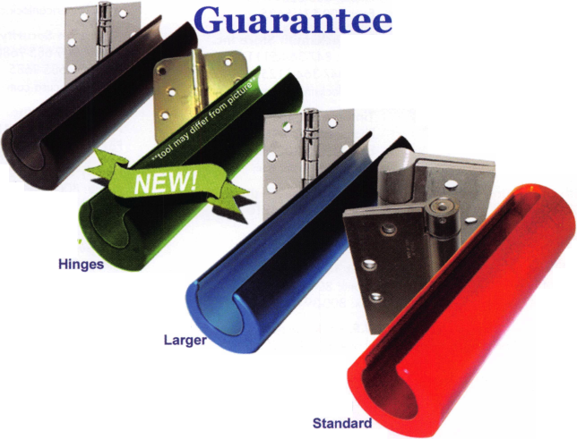

Distributor

**ADI Inc**

Phone: 631-692-1000 Fax: 631-692-3011

**Accredited Lock Supply Co**

Phone: 800-652-2835 Fax: 201-865-0030 [www.acclock.com](http://www.acclock.com)

**Ace Lock & Security Supply**

Phone: 800-223-5625 Fax: 908-688-2442 [www.acelock.com](http://www.acelock.com)

**Andrews Wholesale Lock Supply**

Phone: 717-272-7422 Fax: 717-274-8659 [www.andrewslock.com](http://www.andrewslock.com)

**Boyle & Chase Inc**

Phone: 800-325-2530 Fax: 800-205-3500 [www.boyleandchase.com](http://www.boyleandchase.com)

**Clark Security Products**

Phone: 888-784-1311 Fax: 619-718-7333 [www.clarksecurity.com](http://www.clarksecurity.com)

**Cook's Building Specialties**

Phone: 505-883-5701 Fax: 505-883-5704

**Dire's Lock & Key Company**

Phone: 303-294-0176 Fax: 303-294-0198

**Direct Security Supply Inc.**

Phone: 800-252-5757 Fax: 800-452-8600

**Discount Key Machines.Com/Busch**

Phone: 800-332-8724 Fax: 407-363-4666

**Doyle Security Products**

Phone: 800-333-6953 Fax: 612-521-0166 [www.doylesecurity.com](http://www.doylesecurity.com)

**Dugmore and Duncan, Inc.**

Phone: 888-384-6673 Fax: 888-329-3846

**E. L. Reinhardt Co., Inc.**

Phone: 800-328-1311 Fax: 651-481-0166 [www.elreinhardt.com](http://www.elreinhardt.com)

**Ewert Wholesale Hardware**

Phone: 800-451-0200 Fax: 708-597-0881

**Fairway Supply, Inc.**

Phone: 214-350-0021 Fax: 214-352-4299 [www.fairwaysupply.com](http://www.fairwaysupply.com)

**Foley-Belsaw Company**

Phone: 800-821-3452 Fax: 816-483-5010 [www.foley-belsaw.com](http://www.foley-belsaw.com)

**Fried Brothers Inc.**

Phone: 800-523-2924 Fax: 215-592-1255 [www.fbisecurity.com](http://www.fbisecurity.com)

**Hans Johnsen Company**

Phone: 214-879-1550 Fax: 214-879-1530 [www.hjc.com](http://www.hjc.com)

**Hardware Agencies, Ltd.**

Phone: 416-462-1921 [www.hardwareagencies.com](http://www.hardwareagencies.com)

**iDN Incorporated**

Phone: 817-421-5470 Fax: 817-421-5468 [www.idn-inc.com](http://www.idn-inc.com)

**intermountain Lock & Supply**

Phone: 800-453-5386 Fax: 801-485-7205 [www.intermountainlock.com](http://www.intermountainlock.com)

**Jo Van Distributors**

Phone: 416-752-2238 Fax: 416-752-7282 [www.jovanlock.com](http://www.jovanlock.com)

**Lockmasters, Inc.**

Phone: 859-885-6041 Fax: 859-885-7093 [www.lockmasters.com](http://www.lockmasters.com)

**Locks Company**

Phone: 800-288-0801 Fax: 305-949-3619

**Locksmith Ledger International**

Phone: 770-886-0800 Fax: 770-889-7703 [www.lledger.com](http://www.lledger.com)

**M. Zion Company**

Phone: 212-349-8677 Fax: 212-964-0495 [www.mzion.com](http://www.mzion.com)

**McDonald Dash Locksmith Supp**

Phone: 800-238-7541 Fax: 901-366-0005 [www.mcdonalddash.com](http://www.mcdonalddash.com)

**Monaco Lock Co.**

Phone: 800-526-6094 Fax: 800-845-5625 [www.monacolock.com](http://www.monacolock.com)

**Omaha Wholesale Hardware**

Phone: 800-238-4566 Fax: 402-444-1664 [www.omahawh.com](http://www.omahawh.com)

**RA-Lock Company**

Phone: 972-775-6301 Fax: 972-775-6316 [www.ralock.com](http://www.ralock.com)

**Security House**

Phone: 905-669-5300 Fax: 905-660-6313 [www.securityhouselock.com](http://www.securityhouselock.com)

**Security Lock Distributors**

Phone: 800-847-5625

Fax: 800-878-6400

[www.securitylockdistributors.com](http://www.securitylockdistributors.com)

**Shin-An Enterprise Inc**

Phone: 718-225-5380 Fax: 718-819-0723

**Southern Lock and Supply Co.**

Phone: 727-541-5536 Fax: 727-544-8278 [www.southernlock.com](http://www.southernlock.com)

**Stone & Berg Wholesale**

Phone: 800-225-7405 Fax: 800-535-5625

**The Locksmith Store Inc.**

Phone: 847-364-5111 Fax: 847-364-5125 [www.locksmithstore.com](http://www.locksmithstore.com)

**Timemaster Inc**

Phone: 859-259-1878 Fax: 859-255-0298 [www.time-master.com](http://www.time-master.com)

**Top Notch Distributors, Inc.**

Phone: 800-233-4210 Fax: 800-854-4146 www.4topnotch .com

**Turn 10 Wholesale**

Phone: 800-848-9790 Fax: 800-391-4553

**U.S. Lock Corp.**

Phone: 800-925-5000 Fax: 800-338-5625 [www.uslock.com](http://www.uslock.com)

Manufacturer

**A & B Safe Corporation**

Phone: 800-253-1267 Fax: 856-863-1208 [www.a-bsafecorp.com](http://www.a-bsafecorp.com)

**ABUS Lock Company**

Phone: 800-352-2287 Fax: 602-516-9934 [www.abus.com](http://www.abus.com)

**Adams Rite Mfg Company**

Phone: 800-872-3267 Fax: 800-232-7329 [www.adamsrite.com](http://www.adamsrite.com)

**Adesco Safe Mfg. Company**

Phone: 800-694-9340 Fax: 562-408-6427 [www.adesco.com](http://www.adesco.com)

**Adrian Steel Company**

Phone: 800-677-2726 Fax: 517-265-5834 [www.adriansteel.com](http://www.adriansteel.com)

**All Five Tool Company, Inc.**

Phone: 860-583-1691 Fax: 860-583-4516 [www.all5tool.com](http://www.all5tool.com)

**American Lock Company**

Phone: 708-534-2000 Fax: 708-534-0531 [www.armericanlock.com](http://www.armericanlock.com)

**American Security Products**

Phone: 909-685-9680X1083 Fax: 909-685-9685 [www.amsecusa.com](http://www.amsecusa.com)

**Bianchi USA, Inc.**

Phone: 800-891-2118 Fax: 216-803-0202

**Buddy Products**

Phone: 800-886-8688 Fax: 312-733-8356 [www.buddyproducts.com](http://www.buddyproducts.com)

**CCL Security Products**

Phone: 800-733-8588 Fax: 847-537-1800

**COMPX Security Products**

Phone: 864-297-6655 Fax: 864-297-9987 [www.nclnet.com](http://www.nclnet.com)

**42**

Keynotes • June 2004

associate

members

**D&D Technologies (USA), Inc**

Phone: 714-677-1300X292 Fax: 714-677-1299 [www.ddtechusa.com](http://www.ddtechusa.com)

**DETEX Corp**

Phone: 800-729-3839 Fax: 830-620-6711 [www.detex.com](http://www.detex.com)

**DORMA Architectural Hardware**

Phone: 717-336-3881 Fax: 717-336-3500 [www.dorma-usa.com](http://www.dorma-usa.com)

**Datakey Electronics**

Phone: 952-746-4066X323 Fax: 866-289-4212 [www.datakeyelectronics.com](http://www.datakeyelectronics.com)

**Don-Jo Manufacturing, Inc.**

Phone: 978-422-3213 Fax: 978-422-3467 [www.don-jo.com](http://www.don-jo.com)

**Door Controls International**

Phone: 800-742-3634 Fax: 800-742-0410 [www.doorcontrols.com](http://www.doorcontrols.com)

**ESP Lock Products Inc.**

Phone: 800-434-8960 Fax: 978-562-9859

**FireKing Security Products**

Phone: 800-457-2424 Fax: 800-896-6606 [www.fkisecuritygroup.com](http://www.fkisecuritygroup.com)

**Framon Manufacturing Company Inc**

Phone: 989-354-5623 Fax: 989-354-4238 [www.framon.com](http://www.framon.com)

**HES, Inc**

Phone: 623-582-4626 Fax: 623-582-4641 [www.hesinnovations.com](http://www.hesinnovations.com)

**HPC, Inc.**

Phone: 847-671-6280 Fax: 847-671-6343 [www.hpcworld.com](http://www.hpcworld.com)

**HY-KO Products Co.**

Phone: 440-232-8223X3095 Fax: 440-232-8227

**Hammerhead Industries, Inc.**

Phone: 805-658-9922 Fax: 805-658-8833 [www.gearkeeper.com](http://www.gearkeeper.com)

**Ingersoll Rand SSA**

Phone: 317-613-8025 Fax: 317-613-8068 [www.schlagelock.com](http://www.schlagelock.com)

**Jet Hardware Mfg., Co.**

Phone: 718-257-9600 Fax: 718-257-0973 [www.jetkeys.com](http://www.jetkeys.com)

**KEY-BAK/West Coast Chain Mfg**

Phone: 909-923-7800 Fax: 909-923-0024 [www.keybak.com](http://www.keybak.com)

**Keri Systems Inc**

Phone: 408-451-2520 Fax: 408-441-0309 [www.kerisys.com](http://www.kerisys.com)

**Knaack Manufacturing Co.**

Phone: 800-456-7865 Fax: 815-459-9097 [www.weatherguard.com](http://www.weatherguard.com)

**LAB Security**

Phone: 800-243-8242 Fax: 860-583-7838 [www.labpins.com](http://www.labpins.com)

**La Gard Inc.**

Phone: 310-325-5670 Fax: 310-325-5615 [www.lagard.com](http://www.lagard.com)

**Lock America, Inc. Dba L.A.I. Gro**

Phone: 714-373-2993 Fax: 714-373-2998 [www.laigroup.com](http://www.laigroup.com)

**Lucky Line Products, Inc.**

Phone: 858-549-6699 Fax: 858-549-3241 [www.luckyline.com](http://www.luckyline.com)

**M.A.G. Security**

Phone: 714-891-5100

Fax:714-892-6845

[www.magsecurity.com](http://www.magsecurity.com)

**MUL-T-LOCK USA, Inc**

Phone: 800-562-351 1 Fax: 973-778-4007 [www.mul-t-lock.com](http://www.mul-t-lock.com)

**Medeco Security Locks**

Phone: 540-380-5000 Fax: 540-380-5010 [www.medeco.com](http://www.medeco.com)

**ROFU International Corp**

Phone: 800-255-7638 Fax: 253-922-1728 [www.rofu.com](http://www.rofu.com)

**Rutherford Controls Int'l Co**

Phone: 757-427-1230 Fax: 757-427-9549 [www.rutherfordcontrols.com](http://www.rutherfordcontrols.com)

**STRATTEC Security Corp.**

Phone: 414-247-3415 Fax: 414-247-3692 [www.strattec.com](http://www.strattec.com)

**Sargent & Greenleaf, Inc.**

Phone: 859-885-9411 Fax: 859-885-3063 [www.sargentandgreenleaf.com](http://www.sargentandgreenleaf.com)

**Sargent Manufacturing Co**

Phone: 800-727-5477 Fax: 888-863-5054 [www.sargentlock.com](http://www.sargentlock.com)

**Schwab Corp**

Phone: 765-447-9470 Fax: 765-447-8278 [www.schwabcorp.com](http://www.schwabcorp.com)

**Securitron Magnalock Corp.**

Phone: 775-355-5625 Fax: 775-355-5636 [www.securitron.com](http://www.securitron.com)

**Security Door Controls**

Phone: 805-494-0622 Fax: 805-494-8861 [www.sdcsecurity.com](http://www.sdcsecurity.com)

**Security Solutions**

Phone: 405-376-1600 Fax: 405-376-6870 [www.securitysolutions-usa.com](http://www.securitysolutions-usa.com)

**Townsteel, Inc.**

Phone: 626-858-5080 Fax: 626-858-3393 [www.townsteel.com](http://www.townsteel.com)

**Trine Access Technology**

Phone: 718-829-2332 Fax: 718-829-6405 [www.trineonline.com](http://www.trineonline.com)

**Videx Inc**

Phone: 541-758-0521 Fax: 541-752-5285 [www.videx.com](http://www.videx.com)

**YSG Door Security Consultants, In**

Phone: 800-438-1951 Fax: 800-338-0965

Service

Organization

**Allstate Insurance Company**

Phone: 800-859-0247 Fax: 847-326-7509 [www.allstate.com](http://www.allstate.com)

**Cross Country Automotive Ser­vices**

Phone: 800-541-2262 Fax: 781-393-0256 [www.argosi.com](http://www.argosi.com)

**Massglass & Door Service**

Phone: 888-742-8837 Fax: 805-497-2255 [www.massglass.com](http://www.massglass.com)

**Webster Safe & Lock Co., Inc**

Phone: 901-332-2911 Fax: 901-332-2878 [www.webstersinc.com](http://www.webstersinc.com)



Keynotes • June 2004

**core**

2003 Stan Haney Award presented  
to S&G in Nicholasville, KY by  
Donald Rule, CML President of the  
ALOA Scholarship Foundation

For those of you who were at the 2003 annual membership  
meeting, you will remember that there was not an award to be  
given. We won't go into why there was not an award, suffice  
to say that the award was indeed presented to Jerry Morgan in  
his office in Nicholasville, KY in mid-October 2003. This was  
my first opportunity to visit the S&G plant and I was duly  
impressed. The tour was conducted by none other than Mr.

S&G himself Brian Costley, CML, CMST. As you can imagine  
the range of products produced by this historic company  
requires many highly qualified individuals who work as a team.

Again I want to thank the Sargent & Greenleaf Company for  
their continued support of the ALOA Scholarship Foundation.

For those of you who were not at the membership meeting last  
July, here is a replay of the presentation speech:

On behalf of the ALOA Scholarship Foundation, I am honored  
to make this presentation of the Stan Haney Award. In 1976,  
Stan Haney started the ALOA Scholarship Fund to benefit lock-  
smiths by awarding educational scholarships to the ALOA con-  
vention. Countless scholarships have been awarded in the  
years since then. There are several recipients in this room. In  
1989, I was awarded a scholarship to the ALOA convention in  
Atlanta. I have benefited immeasurably from that award. Just  
look where I am today, I work really hard for no pay. Also in  
1989, Sargent & Greenleaf made the first yearly donation to  
the ASF of $2,000. Not only is this a token of S&G's support  
of our industry, but it serves to honor a truly great man who  
was instrumental in the growth of S&G and the advancement of  
locksmith and safe technician training. The Harry C. Miller  
Scholarship Award is not only S&G's tribute to one of its most  
important historical figures, but also recognizes that the training  
programs conducted by ALOA provide valuable experiences to  
a broad cross section of security professionals. The long-stand-  
ing relationship between S&G and ASF exemplifies the spirit of  
sharing and goodwill that Harry Miller personified. S&G has  
also in the last two years been a co-sponsor of the ASF kickoff  
party. To the best of our knowledge S&G has donated in  
excess of $50,000 through the years to ALOA, ASF and  
SAVTA. I now present the 2003 Stan Haney Award to Mr. Jerry  
Morgan president and chief executive officer of Sargent &  
Greenleaf. Be sure to send your reservation for the 2004  
ALOA Convention & Security Expo in Baltimore, MD. July 13 to  
19, 2004. The Scholarship Foundation Kickoff Party and Live  
Auction will be held Thursday July 17, 2004 at 7 p.m. We  
hope to see you there!

NEW CERTIFICATIONS

|  |  |
| --- | --- |
| David A. Firestone | CML |
| Kathy A. Zaniolo | CML |
| Elliott Connor | CPL |
| Gary L. Perry | CPL |
| Edward R. Woods | CPL |
| Jeffrey C. Reese | CPL |
| Michael T. Sullivan | CPL |
| Brian Batz | CPL |
| Billy G. Bartram | CRL |
| Cecil D. Neill | CRL |
| Christopher Parks | CRL |
| John F. Sartain | CRL |
| Charles H. Saylor | CRL |
| Dale D. Bigelow | CRL |
| Richard Morningstar | CRL |
| Patrick D. Moseng | CRL |
| Noel L. Schanilec | CRL |
| Mark Wicht | CRL |
| Arthur J. Bingham | CRL |
| Sherwood T. Hanson | CRL |
| Brydon Koga | CRL |
| Kent Piesbergen | CRL |
| Shane Varney | CRL |
| Robert H. Whittaker | CRL |
| Jeffrey G. Baldwin | CRL |
| Troy G. Mitchell | CRL |
| William K. Ortmann | CPL |
| Matthew K. Carr | CRL |
| David Andino | CRL |
| David A. Crawford | CRL |
| Charles C. Mark | CRL |
| Steven E. Nitkowski | CRL |
| Mark Ryan | CRL |
| Perry Stillwell | CRL |
| Winston E. Miller | CPS |
| William Young | CPS |

The jSafc and Vault Technicians association  
donnention and Trade 0hom

March 6—*12*, *200*S

***Hyatt Regency, Lexington (Cf***

**tv-**

never been more important for us safe technicians. Let me tell ya, you  
gotta stay aware of what today's top safe distributors and manufacturers  
are putting out there. It's crucial to making a humdinger of a purchasing  
decision, buddy. And another thing, time is of the essence when it  
comes to education. New things pop up every day, Daddy-O, and that  
makes top-notch safe classes as good as gold. The only chance to get  
world-class education and meet with the industry's top distributors  
and manufacturers is the SAFETECH Convention and Trade Show.

Boy, is it swell! SAFETECH 2005 offers you a chance to meet with  
potential customers and bolster business in ways you never thought  
possible. Discover the safes of tomorrow! Gee whiz, jump and jive  
your way into Safetech 2005, and you'll be part of our knock 'em,  
sock'em show of all shows!!

***Safetech Oisits Seautifui Lexington, Kentuckql***

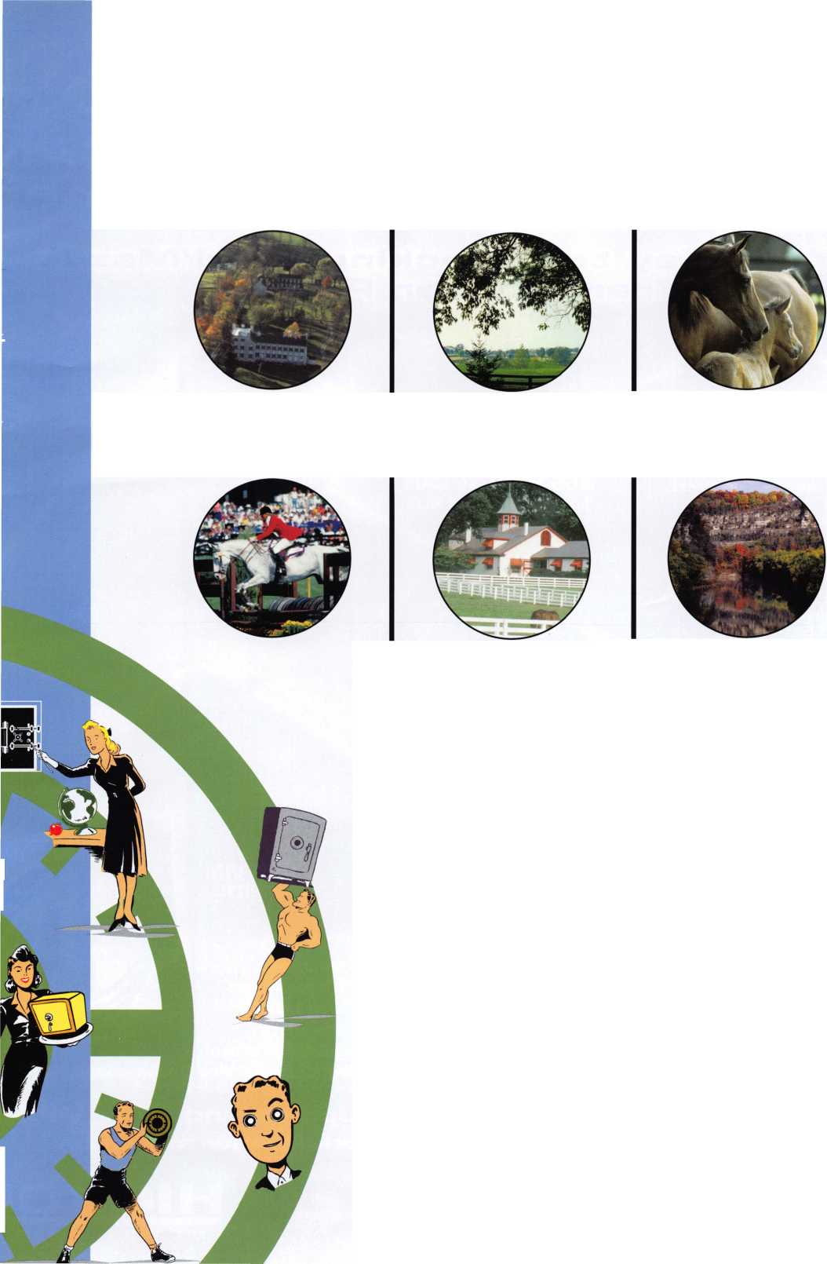

Now

**"I've lost my Taurus keys... can you make me a new set?'**

**How much of your money have you sent to the local Ford Dealer?**

**IMGS STAR XL CAN Locksmith 8008LXLC**

**Did you Know...**

**...the Dealers charge an average of $100 per transponder key?**

**...you can get the factory transponder tool for less than the cost of doing one key per month?**

**CAN VIM**

**81201L**

**Use what the Dealers use for complete N**

**coverage on ALL Ford/Lincoln-Mercury and \**

**Mazda vehicles equipped with transponder keys. The NGS XL CAN offers complete transponder coverage including CAN protocol and the ability to clear ALL Diagnostic Service Codes**

**2004 Software Update and CAI>I Vehicl Interface Module now available.**

**Waekon/Hickok Inc. 2004 All riqhts reserved.**

|  |  |  |  |  |  |
| --- | --- | --- | --- | --- | --- |
|  |  |  |  |  | Si |
| •/i |  |  |  |  |  |

